Historical Thinking Skills
There are several broad historical thinking skills that are assessed in the AP Exam.
Historical Argumentation: Historical thinking involves the ability to define and frame a question about the past and to address that question by constructing an argument. A plausible and persuasive argument requires a clear, comprehensive and analytical thesis, supported by relevant historical evidence—not simply evidence that supports a preferred or preconceived position. Additionally, argumentation involves the capacity to describe, analyze and evaluate the arguments of others in light of available evidence.
Translation: You need to be able to create solid arguments that are supported by evidence.
Use of Relevant Historical Evidence: Historical thinking involves the ability to identify, describe and evaluate evidence about the past from diverse sources (including written documents, works of art, archaeological artifacts, oral traditions and other primary sources), with respect to content, authorship, purpose, format and audience. It involves the capacity to extract useful information, make supportable inferences and draw appropriate conclusions from historical evidence while also understanding such evidence in its context, recognizing its limitations and assessing the points of view that it reflects. It also involves the ability to describe, analyze, evaluate and create diverse interpretations of the past — as revealed through primary and secondary historical sources — through analysis of evidence, reasoning, contexts, points of view and frames of reference.
Translation: You need to be able to analyze both primary and secondary sources and use them to draw and support conclusions. You should also be able to explain how and why these sources differ in terms of information, point of view, and reliability.
Contextualization: Historical thinking involves the ability to connect historical developments to specific circumstances in time and place, and to broader regional, national or global processes.
Translation: You need to be able to explain how an event/idea fits into a given time period. You should also be able to explain how different aspects of a time period influence events and ideas, and be able to explain which were the most significant.
Causation: Historical thinking involves the ability to identify, analyze and evaluate multiple cause-and-effect relationships in a historical context, distinguishing between the long-term and proximate.
Translation: You need to be able to explain cause and effect relationships, both short and long term. You need to be able to explain the relationships between causes and effects, the differences between primary and secondary causation, and assess the relative influence of both causes and effects.
Continuity and Change Over Time: Historical thinking involves the ability to recognize, analyze and evaluate the dynamics of historical continuity and change over periods of time of varying lengths, as well as relating these patterns to larger historical processes or themes.
Translation: You need to be able to explain not only how and how much a given subject has evolved over time, but why both changes and continuities take place. You also need to be able to explain which of those continuities and changes are most important and why.
Comparison: Historical thinking involves the ability to describe, compare and evaluate multiple historical developments within one society, one or more developments across or between different societies, and in various chronological and geographical contexts. It also involves the ability to identify, compare and evaluate multiple perspectives on a given historical experience.
Translation: You need to be able to explain how similar/how different historical subjects are. You need to be able to explain why those similarities and differences exist, and which are the most important in defining the subject.

Tackling a Short Answer Question
The Short Answer Question (SAQ) is the most straightforward writing assessment on the AP Exam. You will have 40 minutes to respond to three SAQs on the AP exam. There are some things to remember when tackling the SAQ section of the exam:
- One of the SAQs will focus on the skill of analyzing secondary historical evidence. Students could be asked to compare historical interpretations, discuss context or point of view, or discuss evidence that would support the assertions put forth in the excerpt. This question will focus on periods 3 through 8.
- Another SAQ will focus on the skill of either comparison or causation, and require students to analyze a primary or visual source. This will also focus on periods 3 through 8.
- The final SAQ will focus on either comparison or causation (whichever was not addressed by the previous question) and will have no stimulus. Students will have a choice between two SAQs for the final question: one option will focus on periods 1 through 5; the other will focus on periods 6 through 9. Both options will focus on the same skill.

Here are some important things to remember when responding to a SAQ:
- SAQs DO NOT require students to develop and support a thesis statement.
- SAQs DO require that responses be in complete sentences. Simply providing a bulleted list is not enough.
- Read the question carefully. There will always be three tasks to perform and three points to be earned.
- Label the responses, (a), (b), and (c) to make it easier for the reader to score and give credit.
- Do the tasks in order (within each question), there usually is a natural progression of ideas.
- Make sure you are clear about what task you are being asked to do and make sure you are clear about the parameters of the task (e.g. the time frame, the people/groups involved, etc.) ● Read and quickly annotate primary and secondary excerpts.
- Discern the audience, point of view, purpose, or context for visual sources.
- DO NOT quote from the documents.
- Be specific. Specific examples will make your answer stand out and be more convincing to your reader.
- Get to the point.
- Stay within the box, responses outside the box will not be read.
- The bad news is that you only have 23 lines to use for your response.
- The good news is that you have 23 lines for your response. Use them.
- While you can address the SAQs in whatever order you want, make sure you put each response in the correct box.

For each part of the SAQ, you should be able to state an answer to the prompt, provide a relevant example to support your answer, and explain the significance of your example.

Tackling the Essays

The Long Essay Questions and Document Based Questions for the AP exam focus on certain skills.
Causation: Essay prompts will ask students to explain causes AND/OR effects of a given phenomenon or explain the origins of a historical development.
- Explain the major political and economic causes and consequences of the growth of big business in American society from 1870 to 1900.
- An effective essay would be able to explain several causes of the rise of big business and explain the outcomes associated with them.
- The thesis of this essay would assert what the overall most important cause or the overall most important effect of the rise of big business was and would develop that idea over the course of the essay.
- Over the course of the essay, a sophisticated essay would be able to discuss the difference between primary and secondary causes and/or between short and long-term effects. Ultimately, the essay would assess which of the causes and/or effects were most important or influential.
Continuity and Change Over Time: Essay prompts will ask students to look at a historical development over the course of a given time period and assess BOTH continuities (similarities) AND changes.
- Evaluate the extent of change and continuity in the lives of African Americans in the South during the period 1865 to 1905.
- An effective essay would be able to explain BOTH continuities AND changes in the lives of African Americans over the course of this period. An essay could be arranged either by topic, showing continuities and changes in each, or with paragraphs on continuities and changes.
- The thesis of this essay would assert whether there was more continuity or more change in the lives of African Americans, and be able to explain why that was the case over the course of the essay.
- While the essay is focused on how things were at the beginning and end of the period, students should be able to explain how events between these bookends led to continuities and changes.
- A sophisticated essay would be able to address which developments were most important in influencing the patterns of continuity and change that occurred.
Comparison: Essay prompts will ask students to look at two historical developments (or regions, groups, etc.) and address BOTH similarities AND differences.
- Compare and contrast the New England colonies with the colonies in the Chesapeake. Be sure to address two of the three characteristics in your answer: political, economic, and social patterns.
- An effective essay would be able to explain similarities and differences. In essence, a Comparison essay requires that you both compare and contrast.
- The thesis of this essay could assert whether the New England and Chesapeake colonies were more similar or more different from each other, or it could put forth an argument about why there were significant similarities or differences. For example, the thesis for this essay could assert that geography was the driving force behind the development of differences between the three regions.
- A sophisticated essay would address which were the most important similarities or differences, and explain why.

Getting Your Essay Started
First and foremost, students need to realize one simple truth:
IT IS IMPOSSIBLE TO WRITE A GOOD ESSAY ON A TOPIC ABOUT WHICH YOU KNOW NOTHING. While this lesson will address writing style, every rubric requires that you integrate specific, detailed information into your essay; there is no substitute for actually knowing the content.

The first thing that must be addressed is how to tackle the question.
- Read the question or prompt carefully and break it down. Answering the question will be the central focus of your essay. Read the question three times and be able to paraphrase what the question is asking and what type of question (Causation, Continuity and Change Over Time, or Comparison) it is.
Once you have established what the question is asking you to do,
    - Look for a time period, points asked for, etc. Make sure you are aware of the entire question.
    - Look for words in the question that need defining. Often, how you define key terms in the question shapes how you answer the question.
    - Look for ways to answer the question in a sophisticated manner; not with a simple yes or no, or right or wrong. While it is more comfortable to stick with black and white, as historians we must learn to dwell in the gray. Look for multiple points of view.
- Brainstorm on paper everything that comes to mind regarding the topic at hand. You need to think of your brainstorm on two levels:
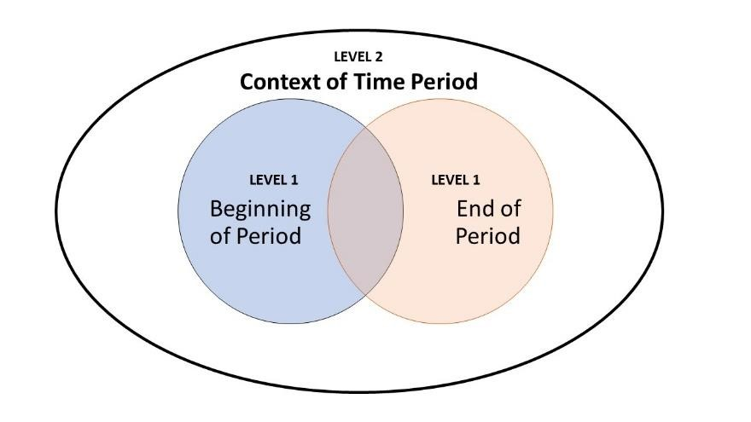
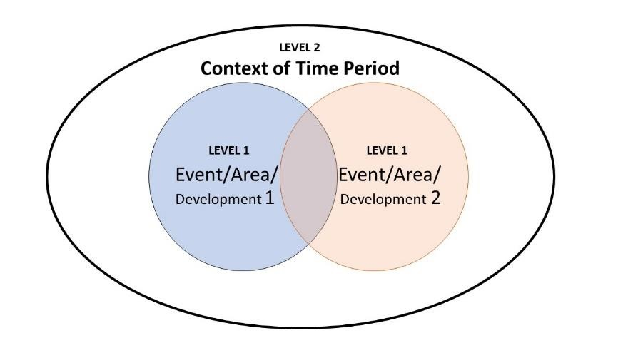
Continuity and Change Over Time

Comparison

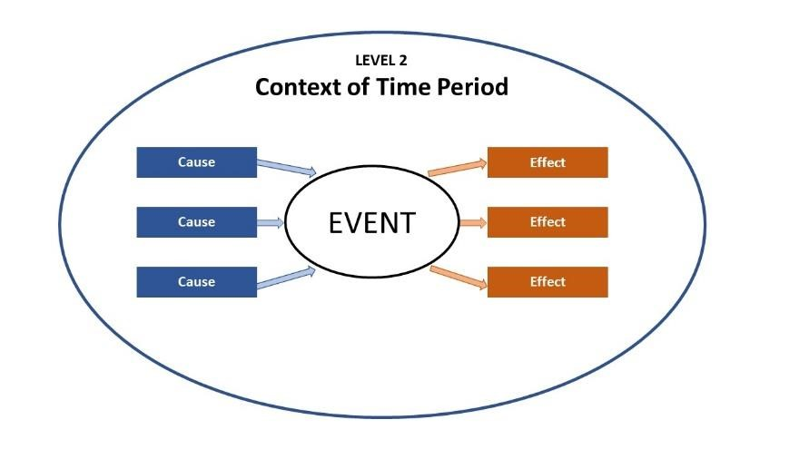
Causation/Contextualization

  - Start with Level 1: What do you know about this particular topic in this particular time period/place? Looking at each of the diagrams above should remind you that you will need to consider multiple elements in your brainstorm: continuities AND changes, similarities AND differences, causes AND effects.
  - Next, Level 2: What do you know about the time period and the time period directly preceding it? Where did this topic come from? What else is going on in this period? How do the events of this time period influence the topic at hand? How does the topic at hand influence or reflect the time period? In short, how does the topic addressed in the question fit into the context of the time period? Being able to explain how the time period influenced the question at hand is important to developing historical understanding.

- Organize your Level 1 information into two to three categories that you can develop into body paragraphs. Establish connections between your Level 1 and 2 brainstorms.

Crafting a Thesis
Crafting a thesis is the first step in historical argumentation, and we will practice this skill regularly over the course of the year. In many ways, your thesis is the lynchpin of your essay. As you are confronted with a question or prompt, your thesis is, in the most basic sense, your answer. However, your thesis does more than that.
First, it is important that you use your thesis statement to establish your argument. Your essay needs to make “a historically defensible claim.” To do so, you want to make sure that you take a stand that you will defend over the course of the essay, rather than setting up a narrative about all that you know about the topic or simply saying that you agree or disagree with the prompt or that “there were similarities and differences.”
Second, you should be able to acknowledge that while you have a strong argument to make, there is more than one side to any argument. Good writers anticipate and deflect counterarguments by offering an occasional concession, even though they are taking one side of the argument. Since the essay prompts could be asking you to address both similarities and differences (or continuities and changes), you need to be able to make an “evaluative claim” which establishes the extent to which the elements you are discussing in your essay are similar or different. In a causation essay, you could also address the relative importance of the causes or effects of an event.
Look at the following examples:

Causation
Explain the major causes and consequences of the market revolution of the early nineteenth century.
A sophisticated student would address both causes and consequences of the market revolution over the course of the essay, but the thesis of the essay would make an assertion about the most important cause or the most important effect.
The market revolution witnessed vast economic expansion that was driven by the rapid evolution of transportation and technology which redefined the American economy and society.

Continuity and Change Over Time
Evaluate the extent to which increasing integration of the United States into the world economy contributed to maintaining continuity as well as fostering change in United States society from 1945 to the present.
With this prompt, a good argument could address whether there was more continuity or more change over the course of this period. The thesis may also put forth an argument about what really was the driving force behind this change, or whether these changes were positive or negative for American society.
While America strove to maintain its place as the manufacturing center of the world, increasing integration into the world economy led to a shift away from traditional industries in the post-World War
II era.

Comparison
Compare the debates that took place over American expansionism in the 1840’s with those that took place in the 1890’s, analyzing the similarities and differences in the debates of the two eras.
In the Comparison question above, a sophisticated student would assert in his/her thesis, for example, that while the two time periods reflect some differences, they are more similar than different. The thesis might also hint at what made them similar.
While technological advances widened the scope of American expansion in the 1890s, there were remarkable similarities between the debates over expansion in the 1840s and 1890s.

It is not necessary to list the categories that you are going to address over the course of the essay in your thesis. While your thesis must address all parts of the question, your “thesis” will be comprised of more than one sentence over the course of the introductory paragraph.

The key thing to remember is that, once you have established an argument in your thesis, you must channel your evidence and analysis back to that argument. Every essay rubric requires that students support their stated thesis using specific evidence, clearly and consistently stating how the evidence supports the thesis, and establishing clear linkages between the evidence and the thesis. The development of your argument is what will propel your essay into the higher scores on the rubrics.

Writing the Introductory Paragraph
The essays on the AP exam are about both content and process. The expectation is that students, as historians, can explain not only a given topic, but also how that topic fits into the context of the time period you are addressing. Your introductory paragraph will establish the structure for both of these goals.
Establishing structure is an essential element of your essay. You want the reader to know what your answer to the question is and how you plan to support it. To that end, you will be required to write your introductory paragraph like this: T-E-L
- Thesis statement - A critical factor present in the opening paragraph is the THESIS. Exam readers appreciate reading the thesis sentence at the very beginning of the essay because it helps them focus on your argument. Simply put, the thesis statement does two things:
  - Serves as the student’s answer to the question.
  - Acknowledges that the student is aware of the complexity of the question.
- Expansion – This is where you put the question at hand into historical context by explaining why this question is arising in this period. Look at the Level 2 information from your brainstorm. How does this topic fit into the broader historical context of the time period? Take two to three sentences to explain how the topic at hand fits into the time period being addressed. This might also be an opportunity to explain any key ideas contained in the prompt or your thesis.
- List – Finally, you will give a quick listing of the main organizational points that will be used to structure and present the data used to defend the thesis. In your Level 1 brainstorm, you fleshed out some categories of information or some key points – list them here so the reader knows where you are going. DO NOT DO THIS IN YOUR THESIS!
By the time the reader has finished reading your introductory paragraph, the reader should know your argument (your answer to the question), the key ideas essential to understanding the stated topic and its place in historical context, and how you will support your argument. Your argument is critical: students that state an argument and include judgment and analysis to build their interpretation into their essay will certainly earn a higher rank than those that build a narrative composition that recites only facts.
Students should stay away from absolutes (never, always, and completely). Remember, historians dwell in the “gray areas” of history. Hence, students should think of issues in terms of a scale of 0-10 when providing analysis of historical issues. Anybody can answer “true or false.” Good students of history address “how true” or “how false.”

Putting Together Your Essay
Body Paragraphs: The number, order, and nature of these paragraphs will be determined by the organizational list in the introductory paragraph. Generally, students should expect two to three body paragraphs, depending on the nature of the question. When in doubt about how many paragraphs you should have, ALWAYS, ALWAYS, ALWAYS ANSWER THE QUESTION!!!

Body paragraphs should be arranged in descending order of importance. Hit the reader with the strongest argument or most prominent facet of the argument first. The only exception to this rule would be in the case where you were going to address topics chronologically. Even then, you would be well-served to be sure to get your strongest point down on paper first.

Body paragraphs should have clear and relevant topic sentences that follow the organizational list from the Introductory Paragraph. A topic sentence does two things: it tells what the whole paragraph is going to be about, and it links the paragraph back to the thesis. For example, assume that you are writing an essay in which your thesis is that the Chesapeake and New England colonial regions had developed differently by 1750, and that you were going to use differences in geography as one of your body paragraphs.

Bad TS: Geography is important.
Bad TS: New England and the Chesapeake developed differently for many reasons.
Good TS: Differences in climate and geography contributed to significant differences in development between the two regions.

Body paragraphs should include specific, detailed information that is linked to your argument. It is imperative that students support their assertions with relevant information by unleashing an avalanche of names, dates, people, bills, pieces of literature, and ideas that are germane to the essay. This is what separates thoughtful essays from random musings and pontification. While the use of evidence is very important, students should not simply laundry list or data dump information without taking into consideration the element of judgment and analysis. You should consistently address the questions of “why?” and “so what?” Don't just tell a story and spit out tons of details… present those details within the context of a thesis.

Over the course of your essay, students should demonstrate their awareness of the complexity of history and historical argument.
In causation and CCOT essays, this can be done by addressing the extent of differences addressing both similarities and differences and explaining why they both exist. This is why you brainstorm in a Venn diagram. and multiple causes and effects for causation essays.
In causation essays, you should be able to address both causes and effects of the phenomenon addressed by the prompt. You could also address which was the most important cause/effect as part of your argument. In any kind of essay, you should be on the lookout for ways to anticipate and deflect counterarguments by making concessions to the other side and addressing them. You could also address the notion of multiple perspectives: how would different groups in the time period address this topic differently?

The vocabulary and narrative style of the essay should be addressed carefully. While your reader will acknowledge that your essay is a rough draft, written under time constraints, one of our goals is to make you a better writer. The verbs used in an essay are a critical element in presenting a more sophisticated and descriptive essay. In conjunction with their adjectives and other descriptive tools, the students should strive to go beyond the more mundane verbs.
To that end, do not use the verbs SHOW, FEEL, or BELIEVE when another stronger verb will work. Note the choice of verb tense. Past tense should be used for past action. The choice of verb reveals judgment and analysis as well as the relevance and merit of the information.

Students must avoid the use of first person in an expository essay. It is understood that the thoughts and ideas within the essay are theirs or those sources cited. First person will only undermine your effectiveness as a writer.

There is no “perfect length.” Please don’t ask how long your essay should be. Handwriting, word choice, sentence structure and other factors play a large role in determining the length of the essay, even though they may not influence how much substance is actually there. Do a thorough job and include both evidence and analysis to support your thesis.

Writing to a Document

One of the most important skills that you will need as a historian is the ability to analyze a document and use it to support a thesis or argument. This is one component of the skill of interpretation.

Analyzing a document
When confronted with a historical document, the first thing you should be able to do is summarize what it says. Take a minute to paraphrase the document in one sentence. This, however, is not analysis. This is summarizing. To analyze a document, you should be able to address the following:
- Source – What do you know about the source? Is it a person? Government agency? Organization? From what perspective is the document written?
- Historical Context – What is going on in this time period? How does this document influenced by the time period? Is this document responding to issues in this period?
- Intended Audience – For whom is this document written? How does the audience influence the message put forth in the document?
- Purpose – What is the author/creator of this document trying to achieve? What impact is the author/creator trying to have on the intended audience?
- Point of View –Do not write this off as just “bias.” This is the culmination of all of the components above. Why is this author putting for this message at this time? Differentiate between the document’s “point” (what the document says and how it says it) and the document’s “point of view” (why the document says what it does the way it does).
- Significance – What does this document say? Why is this document important? What does it reveal about the time period?

Integrating a document into your writing
Now that you’ve analyzed the document, it’s time to do something with it. Your goal as a historian is to make connections between the document and the historical topic at hand. The document, by itself, is pretty useless until you make it relevant.
- Look back at your topic. o If there is an essay prompt associated with this document, how does this document fit with the prompt? How would you use this to make an argument? Does this document fit with any parts of your brainstorm?
  - If you are reading this document in class, what topic is your teacher trying to present? How does this document fit into this context? What does it reveal about the topic? In short, why do you think your teacher had you read/analyze this?
- Summarize the document and make a connection. Be able to summarize the main point of the document and explain how it fits into your argument/discussion of the topic?
- Integrate one of the analytical elements into your discussion, and explain why it’s significant. o You need to be able to explain how historical context, intended audience, author’s purpose, or author’s point of view influenced the document and how it reflects the broader topic or time period.
  - Simply saying “the intended audience was Americans” is not enough. You need to explain why that is significant to the document and its development.
- Do not quote the documents. Anyone can quote the document. You need to provide analysis.
- Cite the document by name.

For example, let’s assume that you are analyzing The Declaration of Independence as a source in a discussion about the origins of the American Revolution.
Bad document usage would look like this: “Document 1 explains why Americans wanted to be free.”

Good document usage would include a summary like this: “The Declaration of Independence outlines the myriad reasons why the colonies wanted to break away from the British empire.” After summarizing, good usage would integrate ONE of these:
- Historical Context: “The Declaration was written in the summer of 1776, more than a year after the first significant battles at Lexington and Concord and after the rejection of the Olive Branch Petition, which was intended to stave off full-out war between the colonies and Britain.” o Note: this is why you need to study and brainstorm. It’s hard to have historical context if you don’t know history
- Intended Audience: “The Declaration was written in very global terms in order to appeal to a worldwide audience – especially France – in the hopes that other nations would be willing to trade with the colonies and provide military or financial aid.”
- Purpose: “The Declaration was intended to not only appeal to Enlightenment thought to justify American rebellion against Britain, it was intended to explain to the rest of the world why the colonies should rebel and why other nations should aid them.” o Note: by now you have noticed, there will be some overlap between some of these elements of analysis.
- Point of View: “Thomas Jefferson wrote the Declaration after being tasked with the job by the Second
Continental Congress, which had voted to declare independence from Britain after significant debate. A lawyer and delegate from Virginia, Jefferson integrated Enlightenment thought into the document to enhance its universal appeal.”

In the wake of this, you would want to explain why this document is significant to the topic or argument at hand.
Remember the concept of “it says, I say, so:”
- It says: Summarize the main idea of the document, as it pertains to the topic at hand.
- I say: Provide some analysis of the document and its meaning. This is where you would integrate one of the HIPP elements. You could also explain how this document pertains to other documents in your essay. ● So… Explain why the document is relevant to your thesis.

Writing the DBQ

The most important thing to remember when responding to a Document Based Question (DBQ) is this: in spite of all the extra materials involved, IT IS AN ESSAY. You should prepare to write a DBQ the same way that you would prepare to write any free response essay. Therefore, the first steps that you should take to tackle the question and begin your essay are the same:
- Read the question and break it down into its component parts.
- Brainstorm on paper everything (the whole bull’s eye) that comes to mind regarding the topic at hand.
- Organize your Level 1 information into two to three categories that you can develop into body paragraphs. Establish connections between your Level 1, and 2 information.
NOTE: YOU SHOULD NOT HAVE LOOKED AT THE DOCUMENTS YET! While the essay does require you to integrate the documents into your response, it is essential that you take the time to brainstorm outside information that will contextualize the documents and the time period. Don’t let the documents completely dictate your response to the question. Essays that simply “connect the docs” will not fulfill the goals of the essay.
- Read the documents:
  - Read the document quickly yet carefully and look for its major point. Underline, circle or identify major points, or jot them down in your notes for your essay.
  - Follow the steps put forth in the Writing to a Document handout.
  - Keep in mind that sources differ in reliability, degree of information (implied vs. stated), and direct application to the topic. The top scores are given to those essays that demonstrate JUDGEMENT and ANALYSIS of the documents.
  - One of the most important things that you can do is think of outside information that would be relevant to this document. Does this document address things that are in your brainstorm? Does it jog your memory about things that you missed? You must be able to put this document in the context of the time period.
- Identify the documents in your chart for use to support your body paragraphs.
  - You goal is to use at least six of the documents. Clearly, you will want to emphasize those that are relevant to the defense of your thesis, but you could use a document to explain an exception or make a concession.
- Begin writing:
  - TEL introductory paragraph, good topic sentences, and outside information are still required.
  - Refer to the guidelines for writing a good Long Essay. They all still apply here.
- Use the documents in a sophisticated manner
The key thing to remember here is that the essay is not ABOUT the documents. It is an essay about the HISTORICAL SUBJECT that uses the documents to support your thesis. This is very important! The AP US history DBQ requires that you have a blend of outside information and document usage to support your case. YOU MUST HAVE BOTH ELEMENTS IN YOUR ESSAY!
When writing your essay, DO NOT QUOTE THE DOCUMENTS; refer to them in context by name NOT BY "DOC. 1." Although you may put (doc. 1) in parentheses at the end of your sentence, that alone is may not be counted as good document usage.
  - Paraphrase the documents to support your major points in your essay, do not rewrite the documents or simply list what each one is about. You must use the documents rather than let the documents dictate your essay.
  - Indicate to the reader that you understand the source and use phrases that demonstrate awareness of the credibility and subtext of each document. You must be able to explain the significance of one of the following for at least three of the documents:
    - Author’s purpose o Intended audience o Author’s point of view o Historical context
    - It doesn’t matter which one you choose, nor do you have to address the same element for each of the documents. As you analyze the documents, look for the element that you think most clearly illustrates the document’s significance to your thesis.
  - Make sure that you use the documents overtly to support your argument. Simply citing the document is not enough.

