Trade Networks 1200- 1450
APWH Project

Big Question
Explain the similarities and differences among the various networks of exchange in the period from 1200-1450.

Introduction
Quick-Notes

Due Date
Wednesday September 22nd

Rubric
 | Score | Feedback/Comments
Annotated Map | ___/15
SPICE Chart- Silk Road  (Responses are specific/detailed, factual/relevant, and organized) | ___/5
SPICE Chart- Indian Ocean  (Responses are specific/detailed, factual/relevant, and organized) | ___/5
SPICE Chart- Trans-Saharan  (Responses are specific/detailed, factual/relevant, and organized) | ___/5
Comparison Venn Diagram  (Responses are specific/detailed, factual/relevant, and organized) | ___/10
Continuity and Change Table  (Responses are specific/detailed, factual/relevant, and organized) | ___/10
Evaluation  (Responses are specific/detailed, factual/relevant, and organized) | ___/10
Most Valuable Traveler  (Responses are specific/detailed, factual/relevant, and organized) | ___/10
LEQ Essay Outline  (Fully complete, typed, and demonstrates high levels of effort) | ___/10
LEQ Essay Introduction Score  (Strong introduction paragraph with contextualization and thesis) | ___/10
Project Layout  (Neat, organized, artistic effort Attention to detail, overall project with obvious plan and layout used, titles clear, drawings or other additions add to the overall appearance) | ___/10
INSTRUCTIONS
Part #1: Annotated Map
Label the following in black:

  - Atlantic Ocean
  - Indian Ocean
  - Mediterranean Sea
  - Black Sea
  - Sea of China
  - Western Europe
  - Eastern Europe
  - Southeast Asia
  - South Asia
  - East Asia
  - Central Asia
  - Middle East
  - North Africa
  - West Africa
  - East Africa
  - Central Africa
  - South Africa
  - Sahara Desert
  - Strait of Malacca
  - Arabian Sea
  - Bay of Bengal
  - Monsoon Winds

Label the following in blue:

- Malacca
- Calicut
- Gujarat
- Spice Islands (Malaysia and Indonesia)
- Timbuktu
- Mecca
- Baghdad
- Córdoba
- Angkor Wat
- Kiev
- Moscow
- Beijing
- Nanjing
- Chang’an
- Hangzhou
- Constantinople
- Great Zimbabwe

OUTLINE each empire/state in a different color (key must be provided)

- Khmer Empire (802- 1431)
- Delhi Sultanate (1206- 1526)
- Mali Empire (1235- 1670)
- Abbasid Caliphate (750- 1258)
- Swahili City-States (1000- 1500)
- Song Dynasty (960- 1279)
- Mongol Empire (1206- 1368)
- Ming Dynasty (1368- 1644)
- Byzantine Empire (330- 1453)
- Feudal Japan (1185- 1603)
- Korea
- Vietnam
- Muslim control of Iberian Peninsula (Moors) (711- 1492)

Outline and label the following trade networks in red:
- Silk Road
- Trans-Saharan
- Indian Ocean

Part #2: SEPTIC Charts
Complete a SEPTIC chart FOR EACH trade network- the Silk Road, Trans-Saharan, and Indian Ocean Trade (three total SEPTIC charts) (minimum two informational bullet-point per SEPTIC theme). Use your AMSCO textbook, vocabulary, trade routes cheat sheet, or class notes to help fill out each SEPTIC chart.

Part #3: Comparison
Compare-and-contrast the Silk Road, Trans-Saharan, and Indian Ocean Trade networks by filling in a three circle Venn Diagram. You must write a minimum of two informational bullet-points per space.

Part #4: Continuities and Changes
Create one continuities and changes table regarding the three trade networks. Think about why and how economies/trade, societies, culture, and politics/government/empires stayed the same or changed as a result of these trade networks from 1200- 1450. Briefly explain these overall continuities and changes (bullet-points are ok).

Part #5: Evaluate
Create a horizontal line on your annotated map. On the far-left, write the following: “Least Influential” and on the far-right: “Most Influential.” Place each of these three trade routes on the spectrum and give two reasons for why you placed each in their respective locations.

Part #6: Most Valuable Traveler
Write a brief summary (1-2 paragraphs) over the life and accomplishments of one of the following travelers: Ibn Battuta, Marco Polo, or Zheng He. Include reasons as to why you believe they are the “most valuable traveler” during this time period and an annotated photo/drawing illustrating their travels.

Part #7: LEQ Essay Outline
Complete the LEQ essay outline (either typed or handwritten). You will need to produce a well written introduction paragraph containing 3-4 sentences of contextualization and a clear and concise thesis statement that directly responds to the prompt. Attach to the back of your project board.
PROJECT DISPLAY
Students will need to neatly organize all completed parts onto a poster board. Posters will need to include at least three relevant photos/drawings (each image must have a brief annotation). Here is an example of possible project organization:
Trade Networks 1200- 1450
Student Name
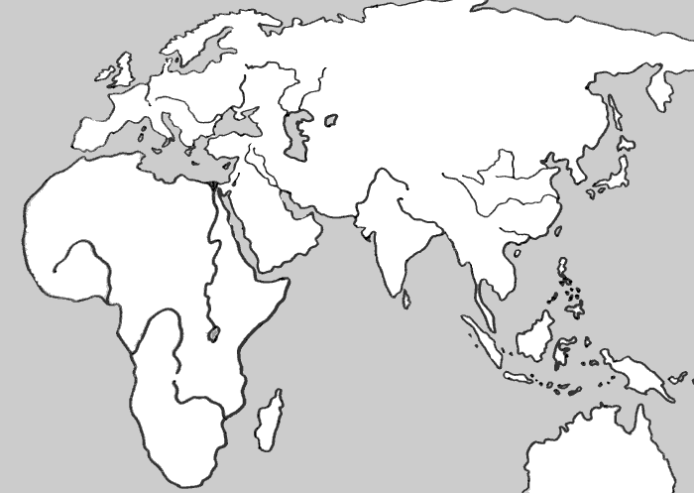
Photo
Key

Photo
Silk Road
S-
E-
P-
T-
I-
C-
Trans-Saharan
S-
E-
P-
T-
I-
C-
Indian Ocean
S-
E-
P-
T-
I-
C-

*Project posters can either be typed or nearly handwritten*

LEQ Essay (Trade Networks) Planning
Prompt: In the period circa 1200 -1450, commerce along exchange networks such as the Silk Road, the Indian Ocean, and the trans-Saharan networks involved a number of new economic and commercial processes.

Develop an argument that evaluates the extent to which developments in economic and/or commercial practices in Afro-Eurasia affected trade in this period.

Analyze the Prompt
What are the key words in this prompt?

Possible Responses
Analyze the following images and review the provided trade networks summary reading. List possible arguments you can make in response to the prompt in the box below.
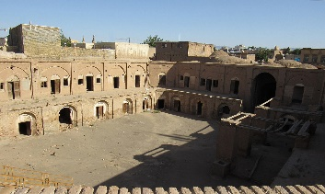
The expansion of empires= people drawn into new economies and trade networks.

Demand for Luxury Goods Increased= Artisans and Merchants Expand Production
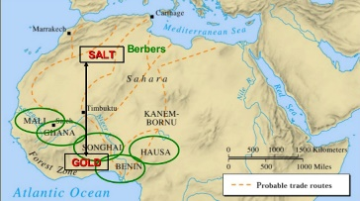

A caravanserai was a roadside inn where travelers could rest and recover

Developed by the Song Dynasty, the Jiaozi was a form of promissory note, regarded as the first paper money in history
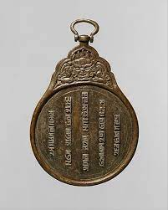
To attract foreign or overseas merchants and talents, the Great Khans gave them paiza exempting them from taxes and allowing them to use relay station

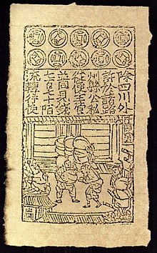

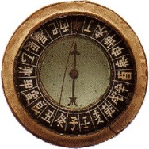
Chinese magnetic compass= help expand navigational opportunities

Essay Outline
*Body Paragraph #1 Main Idea-
Supporting Specific Evidence-

*Body Paragraph #2 Main Idea-
Supporting Specific Evidence-

*Body Paragraph #3 Main Idea (possible complex argument?)-
Supporting Specific Evidence-

Contextualization (Background)
Make a brief list of specific ideas/events/developments that you could write about in your introduction contextualization sentences (must be different than the evidence you will use in your body paragraphs!)
Contextualization ideas…
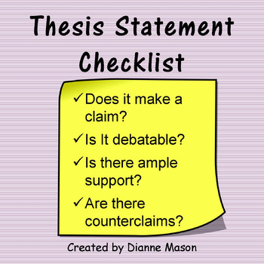
Thesis Formula Ideas
1.) Y because A, B, and C.
2.) X. However, Y because A, B, and C.
3.) Although X, Y because of A, B, and C.
X= Counterargument
Y= Your argument
A= Evidence/Group #1
B= Evidence/Group #2
C= Evidence/Group #3
Thesis Statement

Completed Introduction Paragraph (Contextualization and Thesis Statement)

