Modern Imperialism

Bell-Ringer
What empires have we studied? What makes them an empire?

What is imperialism?

How is “new imperialism” (late 19th and 20th centuries) different from earlier imperial activity, such as the so-called first wave of European colonization between the 15th and early 19th centuries?

Read the following quote and determine how this may have played a role in modern imperialism.

"We are the finest race in the world and the more of the world we inhabit, the better it is for the human race"
- Cecil Rhodes.

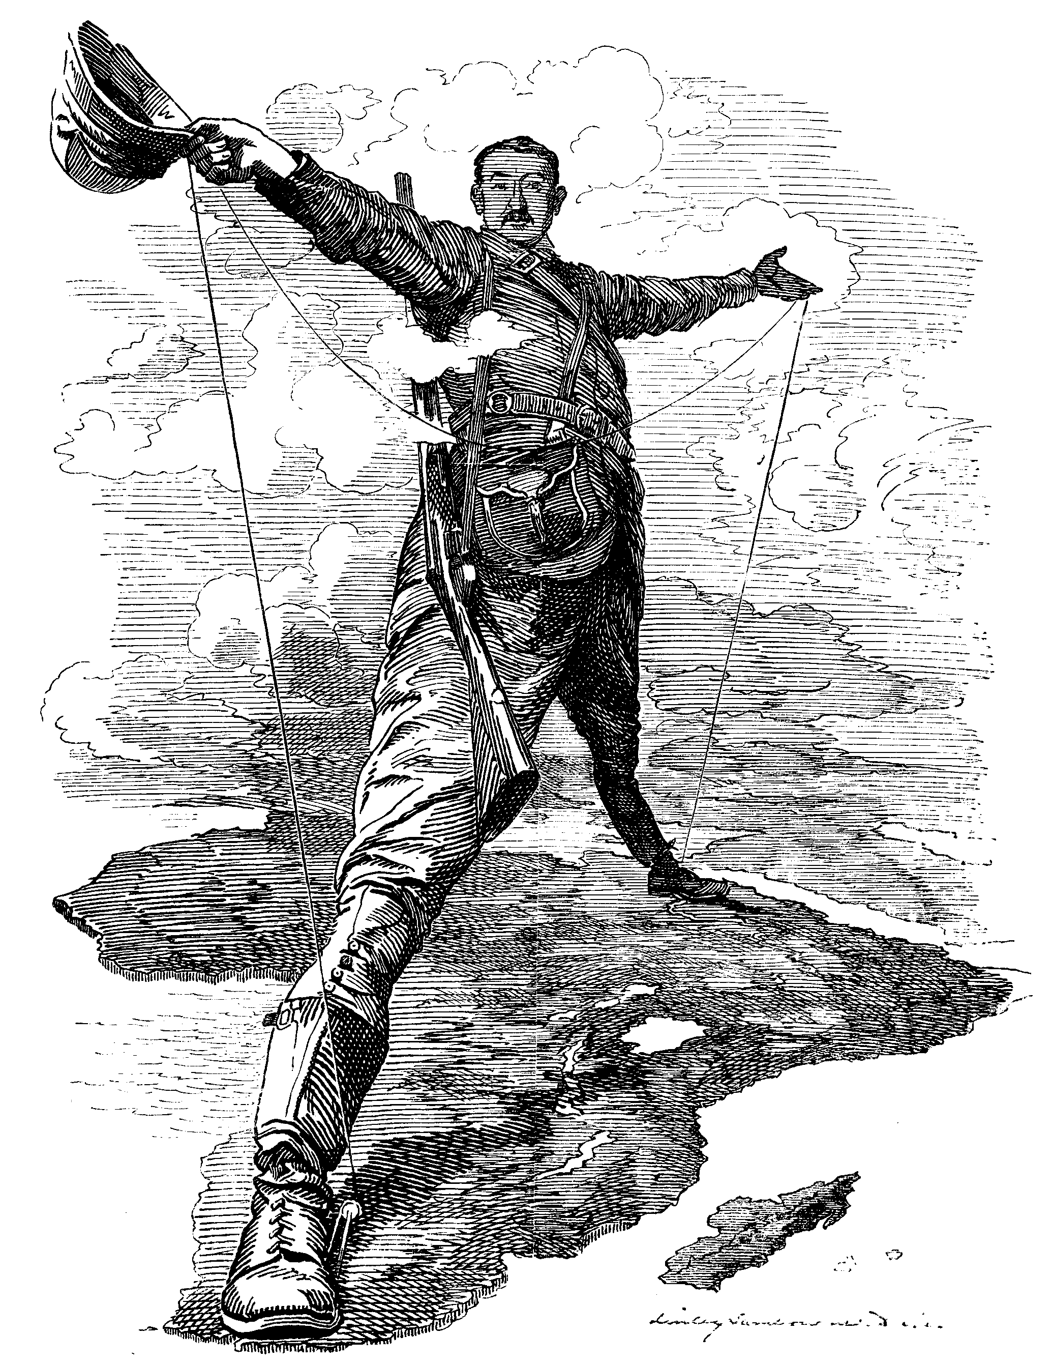
OPTICS

Objects-

People-

Title/Time- The Rhode Colossus (1892) editorial cartoon

Inference-

Conclusion-

The Rhodes Colossus (1892) editorial cartoon
Imperialism

During the era from 1750 to 1900 the forces of nationalism and industrialization made it possible for European nations to build global empires that stretched across the continents. The famous statement that “the sun never sets on the British Empire” describes the huge network of control that Britain was able to establish during the 19th century, making it among the most powerful empires in all of world history.
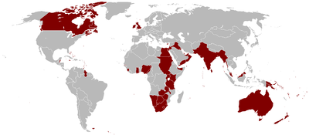

The term “imperialism” was coined to describe the new type of empire-building that began in the 19th century with European nations and eventually included the United States and Japan. These countries did not always take over territories completely as in previous days, but limited control in terms of their motivations. Several types of imperialism could be combined in different ways to gain the power that the imperialistic country wanted:

Colonial Imperialism
Political Imperialism
Economic Imperialism
Social-Cultural Imperialism

The White Man's Burden — The United States and the Philippine Islands
by Rudyard Kipling
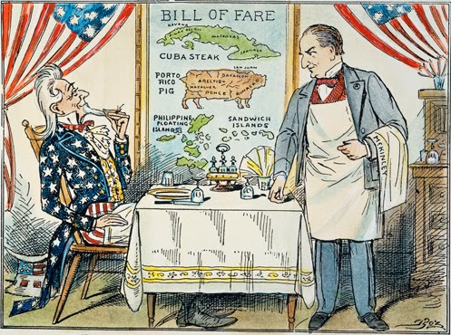
Take up the White Man's burden —
Send forth the best ye breed —
Go bind your sons to exile
To serve your captives' need;
To wait in heavy harness,
On fluttered folk and wild —
Your new-caught, sullen peoples,
Half-devil and half-child.
Take up the White Man's burden —
In patience to abide,
To veil the threat of terror
And check the show of pride;
By open speech and simple,
An hundred times made plain
To seek another's profit,
And work another's gain.
Take up the White Man's burden —
The savage wars of peace —
Fill full the mouth of Famine
And bid the sickness cease;
And when your goal is nearest
The end for others sought,
Watch sloth and heathen Folly
Bring all your hopes to nought.
Take up the White Man's burden —
No tawdry rule of kings,
But toil of serf and sweeper —
The tale of common things.
The ports ye shall not enter,
The roads ye shall not tread,
Go make them with your living,
And mark them with your dead.
Take up the White Man's burden —
And reap his old reward:
The blame of those ye better,
The hate of those ye guard —
The cry of hosts ye humour
(Ah, slowly!) toward the light: —
"Why brought he us from bondage,
Our loved Egyptian night?"
Take up the White Man's burden —
Ye dare not stoop to less —
Nor call too loud on Freedom
To cloak your weariness;
By all ye cry or whisper,
By all ye leave or do,
The silent, sullen peoples
Shall weigh your gods and you.
Take up the White Man's burden —
Have done with childish days —
The lightly profferred laurel,
The easy, ungrudged praise.
Comes now, to search your manhood
Through all the thankless years
Cold, edged with dear-bought wisdom,
The judgment of your peers!
Thoughts?

Spanish-American War (1898)
(Platt Amendment)

Social Darwinism

Industrialization and Imperialism
Industrialization
“Second Industrial Revolution”
Imperialism

Crash Course Video Notes

IMPERIALISM EFFECTS

Foreshadowing?
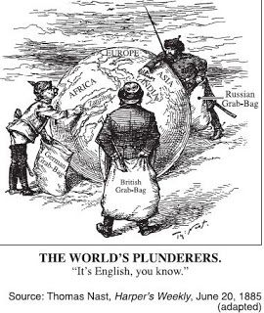

REVIEW IMPERIALISM MAP

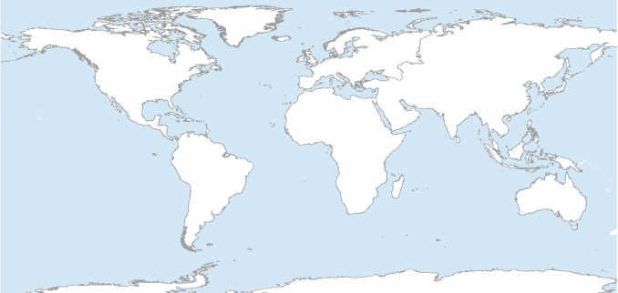

Terms-to-know and label

Suez Canal
Panama Canal
Spanish American War
Nawabs
Company Men
Sepoys
Sepoy Rebellion
Indian Civil Service
Indian Nationalism (Rammohun Roy)
Indian National Congress
Leopold II
“Scramble for Africa”
David Livingstone
Shaka
Zulu
Missionaries
Berlin Conference
Captain James Cook

Emilio Aguinaldo

