MAP #1 QUIZ

- Regions: North America, Mesoamerica, South America, Caribbean, Latin America, Western Europe, Eastern Europe, Russia, the Middle East, Central Asia, East Asia, South Asia, Southeast Asia, Oceania, North Africa, East Africa, West Africa, Sub-Saharan Africa, Antarctica
- Oceans/Seas: Bering Sea/Strait, Pacific Ocean, Indian Ocean, Arctic Ocean, Atlantic Ocean, Southern Ocean

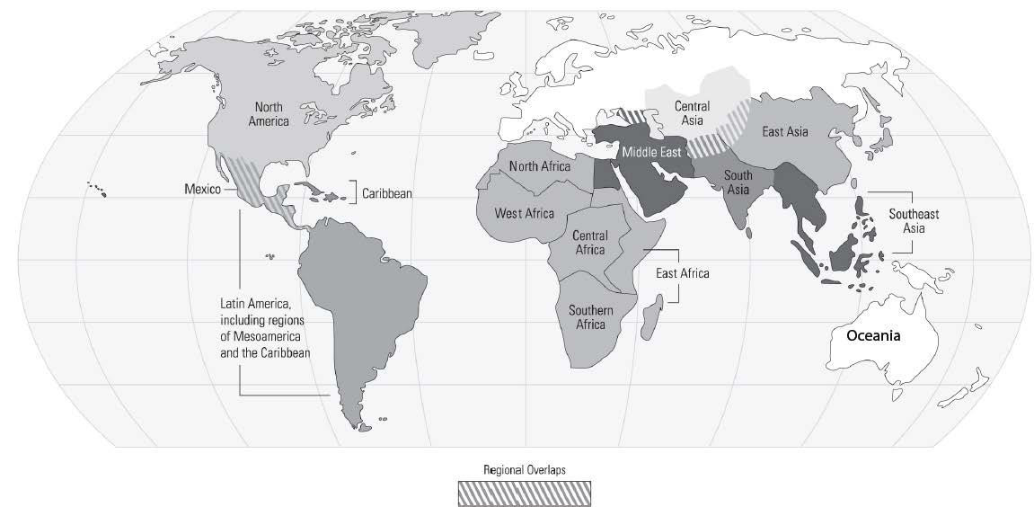

Bodies of Water: Black Sea, Mediterranean Sea, Red Sea, Dead Sea, Caspian Sea, Aegean Sea, Persian Gulf, Euphrates River, Tigris River, Nile River
Regions: Fertile Crescent, Asia Minor (Anatolia), Sinai Peninsula, Mesopotamia, Upper Egypt, Lower Egypt, Sumer
Cities: Thebes, Memphis, Uruk, Babylon

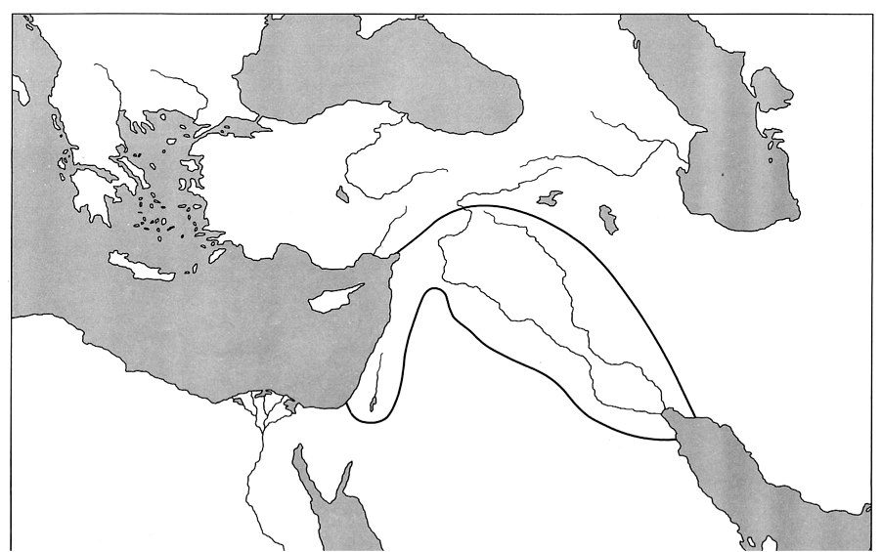

- Regions: North America, Mesoamerica, South America, Caribbean, Latin America, Western Europe, Eastern Europe, Russia, the Middle East, Central Asia, East Asia, South Asia, Southeast Asia, Oceania, North Africa, East Africa, West Africa, Sub-Saharan Africa, Antarctica
- Oceans/Seas: Bering Sea/Strait, Pacific Ocean, Indian Ocean, Arctic Ocean, Atlantic Ocean, Southern Ocean

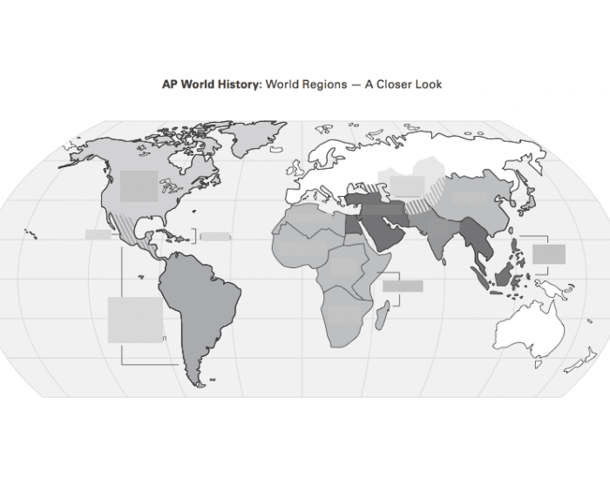

Bodies of Water: Black Sea, Mediterranean Sea, Red Sea, Dead Sea, Caspian Sea, Aegean Sea, Persian Gulf, Euphrates River, Tigris River, Nile River
Regions: Fertile Crescent, Asia Minor (Anatolia), Sinai Peninsula, Mesopotamia, Upper Egypt, Lower Egypt, Sumer
Cities: Thebes, Memphis, Uruk, Babylon

