LEQ Essay (Trade Networks) Planning
Prompt: In the period circa 1200 -1450, commerce along exchange networks such as the Silk Road, the Indian Ocean, and the trans-Saharan networks involved a number of new economic and commercial processes.

Develop an argument that evaluates the extent to which developments in economic and/or commercial practices in Afro-Eurasia affected trade in this period.

Analyze the Prompt
What are the key words in this prompt?

Possible Responses
Analyze the following images and review the provided trade networks summary reading. List possible arguments you can make in response to the prompt in the box below.
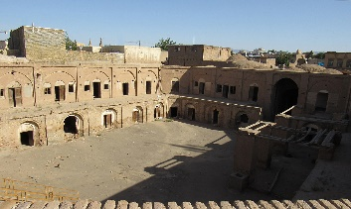
The expansion of empires= people drawn into new economies and trade networks.

Demand for Luxury Goods Increased= Artisans and Merchants Expand Production
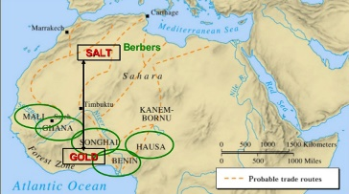

A caravanserai was a roadside inn where travelers could rest and recover

Developed by the Song Dynasty, the Jiaozi was a form of promissory note, regarded as the first paper money in history
To attract foreign or overseas merchants and talents, the Great Khans gave them paiza exempting them from taxes and allowing them to use relay station

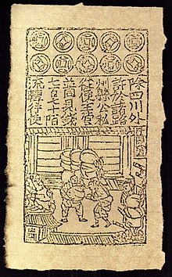

Chinese magnetic compass= help expand navigational opportunities

Essay Outline
*Body Paragraph #1 Main Idea-
Supporting Specific Evidence-

*Body Paragraph #2 Main Idea-
Supporting Specific Evidence-

*Body Paragraph #3 Main Idea (possible complex argument?)-
Supporting Specific Evidence-

Contextualization (Background)
Make a brief list of specific ideas/events/developments that you could write about in your introduction contextualization sentences (must be different than the evidence you will use in your body paragraphs!)
Contextualization ideas…
Thesis Formula Ideas
1.) Y because A, B, and C.
2.) X. However, Y because A, B, and C.
3.) Although X, Y because of A, B, and C.
X= Counterargument
Y= Your argument
A= Evidence/Group #1
B= Evidence/Group #2
C= Evidence/Group #3
Thesis Statement

Completed Introduction Paragraph (Contextualization and Thesis Statement)

