LEQ Essay (Mongol Effects) Planning
Prompt: Compare the political and economic effects of Mongol rule on TWO of the following regions: China, Middle East, Russia.

Analyze the Prompt
What are the key words in this prompt?

Possible Responses
Analyze the map below and determine which khanate controlled the regions of China, the Middle East, and Russia. Briefly list how each of these regions were affected by Mongol rule in the box.
Russia
Khanate Name:
Mongol Effects:

China
Khanate Name:
Mongol Effects:

Middle East
Khanate Name:
Mongol Effects:
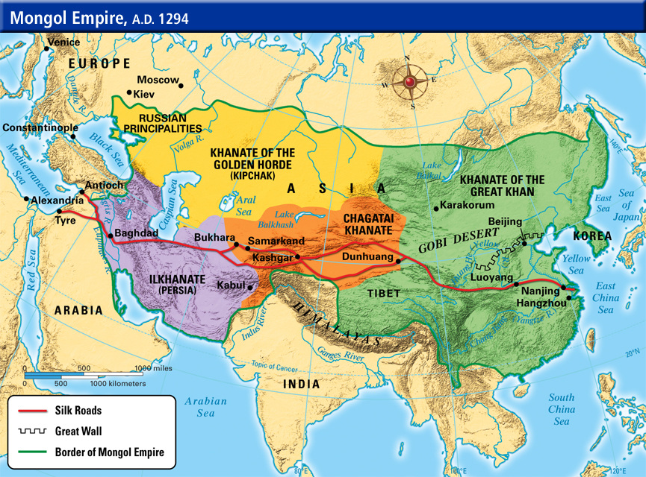

Compare and Contrast
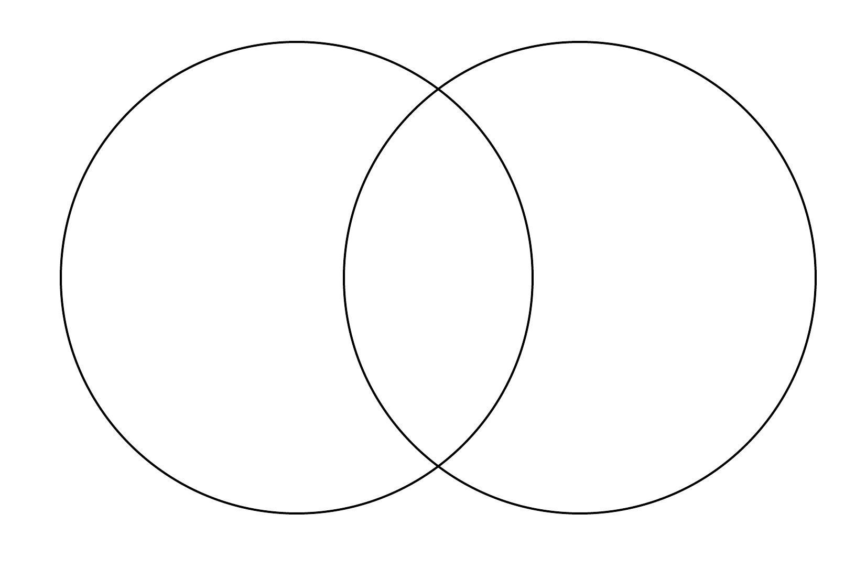
Choose two regions from the prompt and briefly compare (similarities and differences) how they were affected politically and economically by Mongol rule in the Venn Diagram below. Think about which region changed the most- both politically and economically and in the short and long term.

Essay Outline
*Body Paragraph #1 Main Idea-
Supporting Specific Evidence-

*Body Paragraph #2 Main Idea-
Supporting Specific Evidence-

*Body Paragraph #3 Main Idea (possible complex argument?)-
Supporting Specific Evidence-

Contextualization (Background)
Make a brief list of specific ideas/events/developments that you could write about in your introduction contextualization sentences (must be different than the evidence you will use in your body paragraphs!)
Contextualization ideas…

Thesis Formula
Although counterargument, main argument because A, B, and C.

Thesis Statement

