Discontent in Latin America
➡Directions: Read the text and examine the diagram below, then answer the accompanying questions.

How did the social and ethnic structures in Spanish colonies lead to discontent?

- Creoles → resented being treated as second class citizens by the Peninsulares
- Mestizos and Mulattoes → angered that they were not treated as citizens and did not have the same power as whites
- Native Americans and Africans → angered by enslavement and inhumane treatment

1. Was everyone in the Spanish colonies angry for the same reasons? Explain.

In the 1700s, educated creoles read the work of Enlightenment thinkers. Many creoles were sent to Europe to study as well. While there, young creoles were inspired by the ideals of a revolution and national sovereignty or the authority of a state to govern itself or another state. | 2. How did many creoles come into contact with ideas of revolution and freedom?
In 1808, Napoleon invaded Spain, ousted the Spanish king and placed his brother Joseph in control of Spain and its colonies. Many in Latin America saw this as a moment of weakness and an opportunity to reject foreign rule and demand freedom from the colonial crown. | 3. Why did Latin American leaders decide to fight for their freedom after 1808 versus than at an earlier point?

José de San Martín
Years: 1778-1850
Country: Argentina, Chile, Peru
Colonial Power Fought: Spain

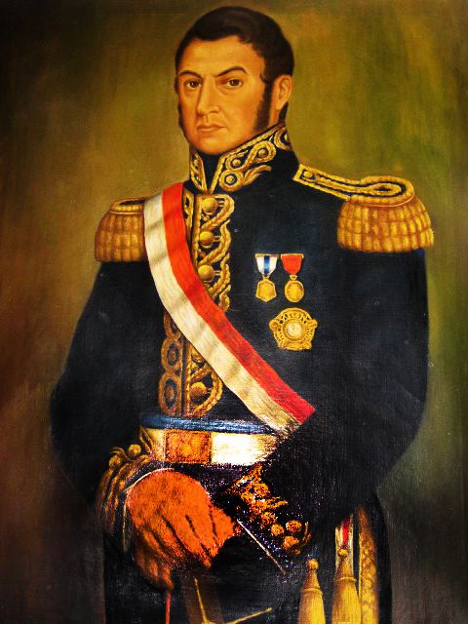  Painting of José de San Martín by unknown painter  Image is courtesy of Wikimedia Commons | José de San Martín was a South American soldier and statesman who played an important role in winning the independence of several South American countries from Spain. José de San Martín was born at Yapeyú, a village on the northern frontier of Argentina, where his father was an official of the Spanish colonial government. At the age of 7, San Martín returned to Spain with his parents. He entered the Royal Academy as a cadet and was educated there with sons of the nobility of Spain. As a member of the Spanish army, he fought in some of the campaigns against French forces in the Peninsular War (a part of the Napoleonic Wars) and by 1811 had acquired the rank of lieutenant colonel.  Hearing of the revolt against Spain in his native Argentina, San Martín resigned from the Spanish army in 1812 and sailed for Buenos Aires to join the patriot forces. He took a prominent part in organizing Argentine troops and soon became military governor of the north to organize defense against Spanish troops in Upper Peru. In 1814, he secured the governorship of the province of Cuyo at the foot of the Andes. Here for 3 years he recruited and trained his Army of the Andes, since he believed that Argentina could not be safely independent unless Spanish forces were dislodged from Chile, Peru, and Bolivia.
 | 1. Why is it significant that San Martín resigned from the Spanish army? How might his military training become useful later?
In January 1817, San Martín led his army of Argentines and fugitives from Chile over the Andes and surprised the Spanish army in Chile. He made Chile completely free of Spanish troops by May 15, 1818, and began planning for an invasion of Peru. Within a year San Martín was able to occupy the capital, and on July 28, 1821, he proclaimed the independence of Peru from Spain. On August 3rd, he accepted the position of supreme protector of Peru.
Adapated from: http://www.biography.com/people/simon-bolivar-241196
2. What impact did San Martín have on Latin American Independence movements?

Simón Bolívar
Years: 1783 – 1830
Country: Venezuela, Ecuador, Bolivia, Peru and Colombia
Colonial Power Fought: Spain

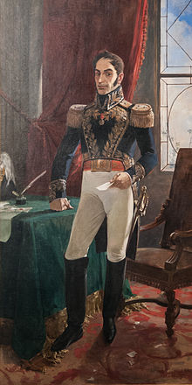  Painting of Simon Bolivar by Arturo Michelena  Image is courtesy of wikimedia commons and is public domain | Simón Bolívar was a Venezuelan military leader who was instrumental in the revolutions against the Spanish Empire. Born into wealth, Bolívar was sent to Spain for his education and quickly got involved in political life in Europe. After France, led by Napoleon Bonaparte, invaded Spain in 1808, he became involved in the resistance movement and played a key role in the Spanish American fight for independence. When Napoleon named Joseph Bonaparte King of Spain and its colonies, which included Venezuela, Bolívar joined the resistance movement. The resistance group based in Caracas gained independence in 1810, and Bolívar traveled to Britain on a diplomatic mission.  Finally, Bolívar returned to Venezuela and began a campaign to take control of that country from the Spanish. He and his followers invaded Venezuela on May 14, 1813. Bolívar was hailed as El Libertador (The Liberator), though civil war soon erupted in the republic, forcing him to flee to Jamaica and seek foreign aid. There he wrote his famous "Letter From Jamaica," detailing his vision of a South American republic with a parliamentary setup modeled after England and a life-long president. In 1825, the "Republic of Bolivia" was created in honor of the inspirational leader, hailed by many as El Libertador (The Liberator).  Adapated from: http://www.biography.com/people/simon-bolivar-241196
 | 1. What impact did the French Revolution and Napoleon have on Simon Bolivar and Venezuela’s independence movement?
 | 2. What impact did Bolívar have on South American independence movements?

Contextualize | Father Hidalgo  Years: 1753-1811  Country: Mexico  Colonial Power Fought: Spain

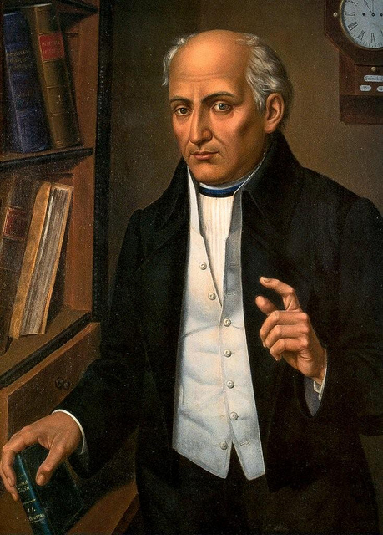  Painting of Father Hidalgo by anonymous painter  Image is courtesy of wikimedia commons and is public domain. | On September 16, 1810, Father Miguel Hidalgo y Costilla, a Roman Catholic priest from the small town of Dolores, Mexico delivered a speech known as The Grito de Dolores ("Cry of/from Dolores") at his church. The event became the start of the Mexican War of Independence (1810-1822) and the Grito de Delores became the battle cry of the Mexican War of Independence.  “My Children, a new dispensation [system of government] comes to us today…Will you free yourselves? Will you recover the lands stolen 300 years ago from your forefathers by the hated Spaniards? We must act at once.”  - Father Hidalgo, Sept 16, 1810  Adapted from: http://www.tamu.edu/faculty/ccbn/dewitt/adp/archives/documents/hidalgo.html, http://www.loc.gov/wiseguide/sept09/independence.html  The events of the French Revolution and the Napoleonic Wars had an influence on the Mexican War for Independence as it did in Haiti and other parts of Latin America. In 1808, Napoleon defeated Spain in Europe and briefly took over the Spanish colonies including Mexico, which was then called “New Spain.” In response, the city council of Mexico City rebelled against the new government and some were jailed. Those who were not and others who supported them created small rebel groups in other parts of Mexico.
 | 1. What impact did the French Revolution have on events in Mexico that led to the Mexican War for Independence?
Miguel Hidalgo y Costilla who led the Mexican independence movement against Spanish rule in 1810 was a part of one of these rebel groups. Born in May 1753 in Guanajuato, Hidalgo entered the priesthood in 1779. For the next quarter of a century, he performed his duties as a spiritual shepherd, but also read texts on political theory including the works of Enlightenment Thinkers. Hidalgo’s underground independence group read books and discussed emerging ideas on nationalism and political liberty.
2. How might reading political texts have influenced Hidalgo’s future role as a revolutionary leader?
When authorities moved to arrest him, he gathered together his followers and his parishioners and issued the “Grito de Dolores” on September 16, 1810, a de facto declaration of independence. He quickly gathered an insurgent army that rampaged through central Mexico. His army, made up of almost 90,000 poor farmers and civilians was defeated by well trained Spanish troops and Hidalgo was taken prisoner by the Spanish and executed, but others continued the fight for Mexican Independence.

Inspired by Hidalgo and other revolutionaries like José María Morelos and Vicente Guerrero, and the ideals of the Enlightenment and French Revolution, upper class Creoles who once supported Spain, started to support Mexican Independence. In 1821, an alliance of the Creole upper class, rebel leaders, and the clergy came together led by the general Agustín de Iturbide to drive the Spanish out of Mexico and declare independence on September 27, 1821.
3. Based on this excerpt, what finally made the Mexican War for Independence successful?

Adapted from:http://www.pbs.org/kera/usmexicanwar/biographies/hidalgo_costilla.html and https://www.history.com/this-day-in-history/spain-accepts-mexican-independence

