Industrial Revolution Sources Search
Primary sources needed for next class:
- Economic (text)
- Political (text)
- Social (text)
- Image/Photograph/Political Cartoon

All excerpts must:
- Be a PRIMARY source relevant to the Industrial Revolution
- EACH text excerpt should be between one to three paragraphs (no more, no less)
- Excerpts should have a clear and organized main point or argument
- Limit Omissions: sentences can be omitted/skipped by adding ellipses (…) to replace extraneous information- however, the author’s overall intended message should not change. If you choose to omit some text from a source, be sure your abridged version flows well and is still in the author’s own words. Don’t “Frankenstein” the text in order to support your own interpretation/ confirmation bias.
- TYPED and PRINTED before class begins (complete the organizer on back)
- List citations and give a brief evaluation/main idea for each source (see example below)

SOCIAL EXAMPLE (text)
Primary Source | Citation | Excerpt or Image (copy/paste) | Brief Evaluation
Social (text) | Excerpt from The Conditions of the Working Class in England, written by Friedrich Engels after he visited an English industrial city (1844) | 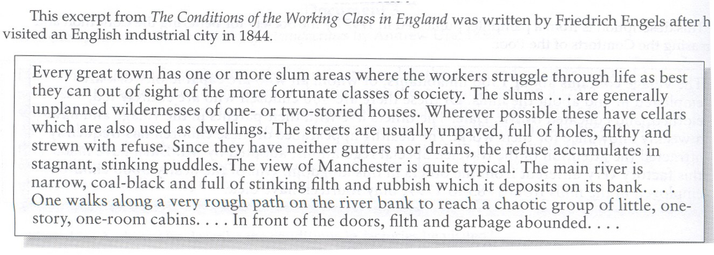 | Working class people generally lived in slum housing (tenements) in cities which were surrounded by filth and a polluted environment

Research tips:
- Look through your AMSCO textbook (specifically the Industrial Revolution chapters)
- Review the notes we took in class and research specific people or events that were discussed (example: googling Adam Smith’s Wealth of Nations excerpts, child labor interviews, or British Parliamentary labor laws from this era).

*The four sources you choose do not need to support or argue against each other. The only correlation they need is that they are all relevant and significant to the Industrial Revolution. *

Primary Source | Citation | Excerpt or Image (copy/paste) | Brief Evaluation
Political (text)

Economic (text)

Social (text)

Image

