Age of Imperialism Notes
Overview
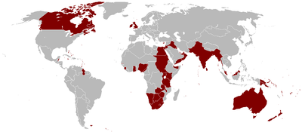
During the era from 1750 to 1900 the forces of nationalism and industrialization made it possible for European nations to build global empires that stretched across the continents. The famous statement that “the sun never sets on the British Empire” describes the huge network of control that Britain was able to establish during the 19th century, making it among the most powerful empires in all of world history.
The term “imperialism” was coined to describe the new type of empire-building that began in the 19th century with European nations and eventually included the United States and Japan. These countries did not always take over territories completely as in previous days, but limited control in terms of their motivations.

Define
In your own words, define the following terms:
Colonization
Imperialism

Crash Course Video (Imperialism)
Watch the following Crash Course YouTube video and briefly describe four major developments during the Age of Imperialism below discussed in the video.
(Imperialism: Crash Course World History #35: https://www.youtube.com/watch?v=alJaltUmrGo)
1.

2.

3.

4.

“Old” versus “New” Imperialism
Compare “old” and “new” imperialism in the Venn Diagram (minimum three bullet points in each section).

SEPTIC Imperialism Causes
Briefly describe the SEPTIC causes for the Age of Imperialism in the table below.
Social
Economic
Political
Technology
Interactions with the Environment
Cultural
Imperialism in Africa (1880- 1914)
Color code the areas of Africa that were colonized by the following European powers and create a key in the provided box below the map, then briefly fill in the boxes around the map.
Scramble for Africa
Significance of the Berlin Conference (1884):

Belgium Congo
Significance of King Leopold II of Belgium:

Research and describe conditions of rubber and ivory workers in the Congo Free State:

Egypt
Significance of Suez Canal to British Empire:

Ethiopia
Significance during Age of Imperialism:

South Africa
Effects of the Anglo-Zulu War:

Research and describe significance of Cecil Rhodes:

South Africa

Imperialism in Asia
South Asia (India)
Using the provided reading packet, internet research, and the following YouTube video clip, briefly describe the sequence of events that eventually led to the British government’s rule over India in the boxes below.
YouTube Video (The Indian Rebellion of 1857): https://www.youtube.com/watch?v=rGoPN3WOBxU
British East India Company
Sepoy Mutiny (1857)
British Raj

East Asia (China versus Japan)
Compare the effects of Western Imperialism on China and Japan (minimum 3 bullet-points in each section).

The British Empire
Objects- Important objects I see are…

People- The person shown is Cecil Rhodes who....

Title/Time- The Rhode Colossus (1892) editorial cartoon

Inference- I can infer the main message of this political cartoon is…

Conclusion- I can conclude the artist’s feelings towards imperialism were…
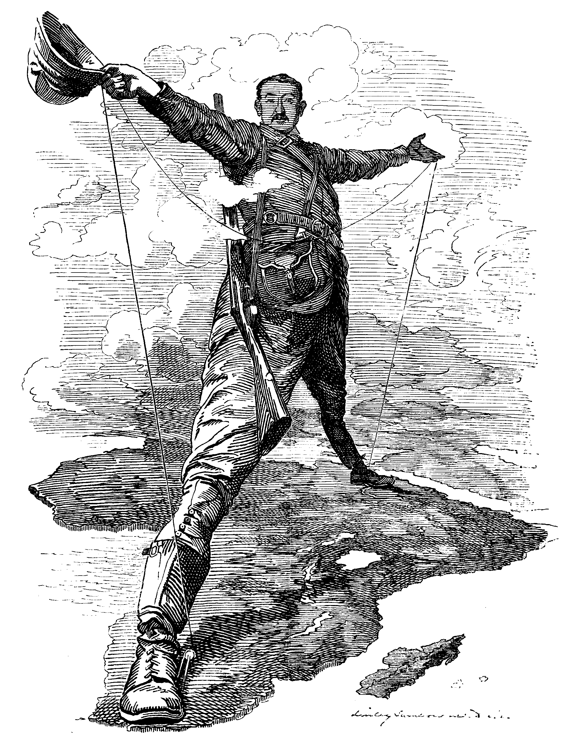

- Read the following quote and explain how this idea may have played a role in modern imperialism: "We are the finest race in the world and the more of the world we inhabit, the better it is for the human race" - Cecil Rhodes.

- Why were the British able to gain decisive advantages in distant lands?

- Why were Asians and Africans so divided, some choosing to cooperate with the Europeans and others resisting their advances?

- How important an advantage were Britain’s weapons, ships, and economic motives?

- By 1870, how much had the British and the different peoples of Africa and Asia gained or lost?

Effects of Imperialism
Create a thinking web listing at least EIGHT specific effects of 19th century imperialism (see example).

