How in the world do I take world history notes?

Taking notes is hard and is a skill that takes time to build- but don’t get discouraged! Here are some basic tips to help you with this learning process.

- Avoid distractions! Reading actively without any background noise or diversions can make it easier to focus and retain information.

- Divide your assigned text into manageable reading sections. I too have a short attention span. Try to break down the chapter into smaller focus sections. Some people recommend breaking reading into 10-page chunks.

- Read actively, not passively! You know that feeling when you’ve just finished any entire page and then think “wait, what did I just read?” Try to avoid that by trying to summarize ideas, connect ideas to other concepts that you’re familiar with, or ask questions to yourself or the text while you read.

- Use tools to aid your understanding. If you don’t understand a word, look it up. Watching a short video online (like Crash Course History on YouTube) before reading the chapter may be helpful as well. If you decide to do this, TAKE NOTES ON THE VIDEO. Pause it and rewind as many times as you need.

- Always read and note the headlines and subtexts. If it's in bold or a different color, it's important.

- Be selective but thorough. You should not write down every piece of information in the book. However, this is easier said than done so here are some basic guidelines.

- Paraphrase information. Paraphrasing information usually shows that you genuinely understood what you read.

- ALWAYS WRITE DOWN KEY WORDS IN THE CHAPTER! Write them somewhere (in your notes or on notecards) that you can refer back to quickly and easily.

- Use a format that works for you. Your notes may take a bulleted list. You might use Cornell Notes. You might draw yourself a timeline of events, flow chart, map, or even simple doodles that will help you remember the information. Adding visual elements can help. Color coding notes helps as well!
*I like to draw cause and effect charts for big events, like wars, or Venn-diagrams to compare two different societies.
EFFECTS
Battles/
People involved
CAUSES (Greco-Persian War)

- Don’t skim the supplementary materials. Be sure that you read and analyze the pictures, charts, graphs, and sources on the sides on the textbook text.

- Learn to write short hand. Write down major names, places, dates, events, and concepts. Follow major concepts with short context clues.

- Summarize your notes at the end. Write out a paragraph or two that summarizes your notes from the chapter. Make it as personal as you can.
*You can also make a SPICE table that summarizes the reading.

- Answer the QUESTIONS listed in each chapter. There are a series of questions located on the side or at the end of a chapter reading. If you are unable to answer those questions, go back to the reading and try to catch what you missed.

- Wait a few days, then review and highlight your notes.
****Compare your notes and talk about the chapter with your fellow classmates. The ability to talk about what you have learned and teach it to others is one of the best tools for retention.****

Sometimes our notes look like a mess at the very end. Consider rewriting them in a more organized/neat manner. Your notes should be something that you are easily able to refer back to when needed.

Cornell Note Format
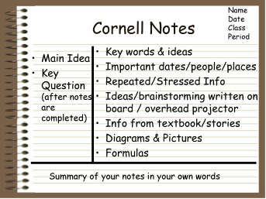

Lastly, remember we are in a learning curve. It is OK to feel frustrated. Just breathe, take a break, and know that as we build these skills, it will get easier with time.

