Gunpowder Empires Notes (1450-1750)
Write 4 important facts from the video:

Part 1: Take Brief Video Notes (Khan Academy)
https://www.youtube.com/watch?v=hNpcQEGw3S4&t=404s
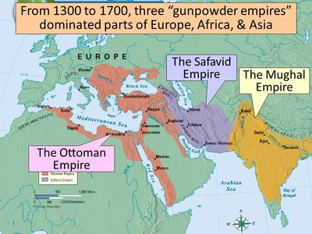

Part 2: Textbook Notes
Briefly Define Gunpowder Empires:

Ottoman Empire (Sunni Muslim)
Location:

Founder:

Fall of Constantinople (1453):

Sulieman the Magnificent Significance:

Political: | Economic: | Social/Cultural:
Define: Janissaries | Define: Devshirme | Define: Tulip Period (look up)

Safavid Empire (Shi’a Islam)
Location:

Branch of Islam (describe):

Ismail Significance:

Political Rivalries with the Ottoman Empire:

Shah Abbas I Significance:

Political: | Economic: | Social/Cultural:

Mughal Empire (Sunni Muslim)
Location:

Rise of the Mughal Empire:

Akbar Significance:

Political: | Economic: | Social/Cultural (specifically gender roles):
Fatehpur Sikri Significance:

Define: Sati | Define: “Divine Faith” | Explain Sikhism Upheaval

Part 3 Venn Diagram: Compare how Ottoman, Safavid, and Mughal rulers used a variety of methods to legitimize and consolidate their power in their respective land-based empire from 1450 to 1750.

