APWH CRAM PACKET:
Period 1 – Technological & Environmental Transformations, to 600 B.C.E. (5% of the APWH Exam) Period 2 – Organization & Reorganization, 600 B.C.E. – 600 C.E. (15% of the APWH Exam)

Climate
Climate has been a major factor in determining where people settled. Peopled settled in areas that has climates that would accommodate agriculture and livestock.

Time Periods • The Paleolithic Age refers to about 12,000 BC. During this time people were nomadic.
- The Neolithic Age refers to the age from about 12,000 BC to about 8000 BC. It is during this time that people settled in communities and civilization began to emerge. • River Valley Civilizations refers to about 3500 to 1500 BC. The major River Valleys are described below.
- Classical Civilizations refers to about 1000 BC to 600 CE. The major civilizations to emerge were Zhou and Han China, Greece and Rome, and the Gupta Empire.

THE RIVER-VALLEY CIVILIZATIONS
Each early civilization developed its own unique ways of life, but they all shared some common characteristics
- Complex irrigation systems
- legal codes
- money
- art and written literature
- More formal scientific knowledge, numbering systems, and calendars
- Intensification of social inequality

COMPARISONS OF EARLY RIVER VALLEY CIVILIZATIONS

 | CULTURE | POLITICAL  ORGANIZATION | SOCIAL  STRUCTURE
MESOPOTAMIA  (developed by  3500 BCE) | Cuneiform;  Extensive trade with Egypt & the Indus  Valley  Epic of Gilgamesh  Early use of bronze tools, chariots  Advanced astronomy; math based on  60  Pessimistic view of the world, perhaps due to irregular, unpredictable flooding of the Tigris & Euphrates rivers  Polytheism – gods powerful/cruel  Kings powerful, but not divine  RIVERS: Tigris & Euphrates | City-states & warrior kings  Hammurabi’s Code  Competition among city-states as well as frequent invasions led  to less political stability than in Egypt | Job specialization – farmers, metallurgists, merchants, craftsmen, political  administrators, priests  Social classes  Marriage contracts; veils for women; women of upper classes less equal than lower-class  counterparts
EGYPT  (developed by  3000 BCE) | Concerned with decorative arts, shipbuilding, some medical knowledge Less advanced in math & astronomy than Mesopotamians Less extensive trade.  Polytheism, with pharaoh as a god Optimistic view of life (regular, controllable flooding of the Nile River) Strong belief in the afterlife; Book of the Dead  Hieroglyphics – complex pictorial language. RIVER: Nile | Divine kingship – the pharaoh; highly centralized, authoritarian  government  Generally stable government throughout the 3 kingdoms  Extensive bureaucracy; pharaoh’s power channeled through regional governors | Smaller nobility than  Mesopotamians; fewer  merchants  Some social mobility through the bureaucracy  Priests have high status (only ones that understand the complex hieroglyphic written language)  Women – probably higher status than in Mesopotamia; love poetry indicates some importance placed on male/female relationships
One female pharaoh –
Hatshepsut
Influential wife of pharaoh - Nefertiti
INDUS VALLEY  (developed by  2500 BCE) | Writing system undecipherable Soapstone seals indicate trade with both Mesopotamia & China  Cruder weapons than Mesopotamians  – stone arrowheads, no swords Polytheism – naked man with horns primary god; fertility goddesses Two cities: Harappa & Mohenjo-Daro RIVER: Indus | Assumed to be complex & thought to be centralized Limited information, but large granaries, plumbing, and cities designed on grid pattern indicate centralized control | Priests have highest status based on position as intermediaries between gods and people.  Differences in house sizes  indicate class distinctions  Statues reflect reverence for female reproductive function
SHANG CHINA (developed by  1700 BCE) | Oracle bones used to communicate with ancestors  Patterns on bones formed basis for writing system; writing highly valued, complex pictorial language with 3000 characters by end of dynasty Uniform written language became bond among people who spoke many different languages  Bronze weapons & tools, horse-drawn chariot  Geographical separation from other civilizations (Gobi Desert & Himalaya Mts.), though probably traded with the  Indus Valley  RIVER: Huang He (Yellow) | Centralized government; power  in the hands of the emperor  Government preoccupied with flood control of the rivers  (Huang He & Yangtze)  Job specialization – bureaucrats, farmers, slaves | Social classes – warrior  aristocrats, bureaucrats, farmers, slaves  Patriarchal society – women as wives & concubines; women sometimes shamans
MESO AND  SOUTH  AMERICA  (developed by  1200 BCE) | Olmecs in Mesoamerica;  Highly developed astronomy; used to predict agricultural cycles & please the gods.  Polytheism; religious rituals important,  shamans as healers  Ritual ball games  Irrigation & drainage canals  Giant carved stone heads, probably  with religious significance  Jaguar symbol important  Chavin in Andean region  Polytheism – statues of jaguar men  Square stone architecture, no mortar Well-developed agriculture based on maize  Unique geography: lived on coast, in mountains, and in jungle | Olmecs: apparently not united politically; unusual for ancient  civilizations  Chavin: probable political unification; public works operated by reciprocal labor obligations; had a capital city | Olmec: craft specializations; priests have highest status; most  people were farmers  Chavin: priests have highest status; capital city dominated hinterlands; most people were farmers

Economic Systems
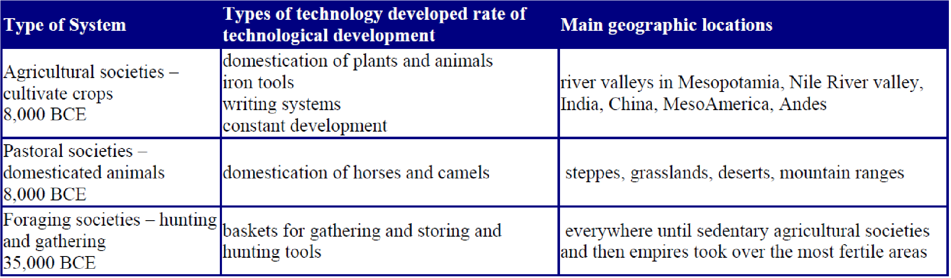

Classical Civilizations
COMMON FEATURES OF CLASSICAL CIVILIZATIONS
The three areas of classical civilizations developed their own beliefs, lifestyles, political institutions, and social structures. However, there were important similarities among them:

- Patriarchal family structures - Like the river valley civilizations that preceded them, the classical civilization valued male authority within families, as well as in most other areas of life.
- Agricultural-based economies - Despite more sophisticated and complex job specialization, the most common occupation in all areas was farming.
- Complex governments - Because they were so large, these three civilizations had to invent new ways to keep their lands together politically. Their governments were large and complex, although they each had unique ways of governing
- Expanding trade base - Their economic systems were complex. Although they generally operated independently, trade routes connected them by both land and sea.

COMPARISONS OF CLASSICAL CIVILIZATIONS

 | CULTURE | POLITICAL  ORGANIZATION | SOCIAL  STRUCTURE
GREECE (about 800-300 BCE) | Most enduring influences come from Athens:  Valued education, placed emphasis on importance of human effort, human ability to shape future events  Interest in political theory: which form of government is best?  Celebration of human individual achievement and the ideal human form  Philosophy & science emphasized Highly developed form of sculpture, literature, math, written language, & record keeping  Polytheism, with gods having many  human characteristics  Cities relatively small  Great sea-faring skills, centered around the Aegean, but traveling around entire Mediterranean area. | No centralized government; concept of polis, or a fortified site that formed the centers of many city-states  Governing styles varied (Sparta a military state, Athens eventually democracy for adult males)  Athens government first dominated by tyrants, strong rulers who gained power through military prowess; later came to be ruled by an assembly of free men who made political decisions.  Both Athens & Sparta developed strong military organizations and established colonies around the Mediterranean. Sparta theoretically equal, wealth accumulation not allowed | Slavery widely practiced  Sparta - Men separated from women in military barracks until age 30; women had relative freedom; women in Sparta encouraged to be physically fit so as to have healthy babies; generally better treated and equal to men than women in  Athens  Athens – encouraged equality for free men, but women and slaves had little freedom. Neither group allowed to participate in polis affairs  Social status depended on land holdings and cultural sophistication

ROME (about  500 BCE to 476 CE, although eastern half continued for another thousand years) | Perfection of military techniques: conquer but don't oppress; division of army into legions, emphasizing organization and rewarding military talent  Art, literature, philosophy, science derivative from Greece  Superb engineering and architecture techniques; extensive road, sanitation systems; monumental architecture buildings, aqueducts, bridges Polytheism, derivative from Greeks, but religion not particularly important to the average Roman; Christianity developed during Empire period, but not dominant until very late  Great city of Rome - buildings, arenas, design copied in smaller cities | Two eras:  Republic - rule by aristocrats, with some power shared with assemblies; Senate most powerful, with two consuls chosen to rule, generally selected from the military Empire - non-hereditary emperor; technically chosen by Senate, but generally chosen by predecessor  Extensive colonization and military conquest during both eras  Development of an overarching set of laws, restrictions that all had to obey; Roman law sets in place principle of rule of law, not rule by whim of the political leader | Basic division between patricians (aristocrats) and plebeians (free farmers), although a middle class of merchants grew during the empire; wealth based on land ownership; gap between rich and poor grew with time  Paterfamilias - male dominated family structure  Patron-client system with rich supervising elaborate webs of people that owe favors to them Inequality increased during the empire, with great dependence on slavery during the late empire; slaves used in households, mines, large estates, all kinds of manual labor
CHINA (about  500 BCE – 600  CE) | Confucianism developed during late Zhou; by Han times, it dominated the political and social structure.  Legalism and Daoism develop during same era.  Buddhism appears, but not influential yet  Threats from nomads from the south and west spark the first construction of the Great Wall; clay soldiers, lavish tomb for first emperor Shi Huangdi Chinese identity cemented during Han era: the "Han" Chinese  Han - a "golden age" with prosperity from trade along the Silk Road; inventions include water mills, paper, compasses, and pottery and silkmaking; calendar with 365.5 days Capital of Xi'an possibly the most sophisticated, diverse city in the world at the time; many other large cities | Zhou - emperor rules by mandate of heaven, or belief that dynasties rise and fall according to the will of heaven, or the ancestors. Emperor was  the "son of heaven." Emperor housed in the forbidden city, separate from all others  Political authority controlled by Confucian values, with emperor in full control but bound by duty Political power centralized under Shi Huangdi - often seen as the first real emperor Han - strong centralized government, supported by the  educated shi (scholar bureaucrats who obtained positions through civil service exams) | Family basic unit of society, with loyalty and obedience stressed Wealth generally based on land ownership; emergence of scholar gentry  Growth of a large merchant class, but merchants generally lower status than scholar-bureaucrats Big social divide between rural and urban, with most wealth concentrated in cities  Some slavery, but not as much as in Rome  Patriarchal society reinforced by Confucian values that  emphasized obedience of wife to husband
INDIA (about  1000 BCE – 550  CE) | Arian religious stories written down into Vedas, and Hinduism became the dominant religion, although Buddhism began in India during this era Mauryans Buddhist, Guptas Hindu  Great epic literature such as the  Ramayana and Mahabarata Extensive trade routes within subcontinent and with others; connections to Silk Road, and heart of Indian Ocean trade; coined money for trade  So-called Arabic numerals developed in  India, employing a 10-based system | Lack of political unity – geographic barriers & diversity of people; tended to fragment into small kingdoms; political authority less important than caste membership & group allegiances  Mauryan & Gupta Empires formed based on military conquest; Mauryan Emperor Ashoka seen as greatest, converted to Buddhism, kept the religion alive  “Theater-state” techniques used during Gupta – grand palace & court to impress all visitors, conceal political weaknesses | Complex social hierarchy based on caste membership (birth groups called jati); occupations strictly dictated by caste Earlier part of time period – women had property rights Decline in status of women during the Gupta, corresponding to increased emphasis on acquisition and inheritance of property; ritual of sati for wealthy women (widow cremates herself in her husband’s funeral pyre)

- The Silk Road - This overland route extended from western China, across Central Asia, and finally to the Mediterranean area. Chinese silk was the most desired commodity, but the Chinese were willing to trade it for other goods, particularly for horses from Central Asia. There was no single route, but it consisted of a series of passages with common stops along the way. Major trade towns appeared along the way where goods were exchanged. No single merchant traveled the entire length of the road, but some products (particularly silk) did make it from one end to the other.
- The Indian Ocean Trade - This important set of water routes became even more important in later eras, but the Indian Ocean Trade was actively in place during the classical era. The trade had three legs: one connected eastern Africa and the Middle East with India; another connected India to Southeast Asia; and the final one linked Southeast Asia to the Chinese port of Canton.
- Saharan Trade - This route connected people that lived south of the Sahara to the Mediterranean and the Middle East. The Berbers, nomads who traversed the desert, were the most important agents of trade. They carried goods in camel caravans, with Cairo at the mouth of the Nile River as the most important destination. There they connected to other trade routes, so that Cairo became a major trade center that linked many civilizations together.
- Sub-Saharan Trade - This trade was probably inspired by the Bantu migration, and by the end of the classical era people south of the Sahara were connect to people in the eastern and southern parts of Africa. This trade connected to the Indian Ocean trade along the eastern coast of Africa, which in turn connected the people of sub-Saharan Africa to trade centers in Cairo and India.

Fall of Civilizations
Recall that all of the river-valley civilization areas experienced significant decline and/or conquest in the time period around 1200 BCE. A similar thing happened to the classical civilizations between about 200 and 600 CE, and because the empires were larger and more connected, their fall had an even more significant impact on the course of world history. Han China was the first to fall (around 220 CE), then the Western Roman Empire (476 CE), and finally the Gupta in 550 CE.

SIMILARITIES
Several common factors caused all three empires to fall:
- Attacks from the Huns - The Huns were a nomadic people of Asia that began to migrate south and west during this time period. Their migration was probably caused by drought and lack of pasture, and the invention and use of the stirrup facilitated their attacks on all three established civilizations.
- Deterioration of political institutions - All three empires were riddled by political corruption during their latter days, and all three suffered under weak-willed rulers. Moral decay also characterized the years prior to their respective falls.
- Protection/maintenance of borders - All empires found that their borders had grown so large that their military had trouble guarding them. A primary example is the failure of the Great Wall to keep the Huns out of China. The Huns generally just went around it.
- Diseases that followed the trade routes - Plagues and epidemics may have killed off as much as half of the population of each empire.

DIFFERENCES
Even though the empires shared common reasons for their declines, some significant differences also may be seen.
- The Gupta's dependence on alliances with regional princes broke down, exhibiting the tendency toward political fragmentation on the Indian subcontinent.
- Rome's empire lasted much longer than did either of the other two. The Roman Empire also split in two, and the eastern half endured for another 1000 years after the west fell.
- The fall of empire affected the three areas in different ways. The fall of the Gupta probably had the least impact, partly because political unity wasn't the rule anyway, and partly because the traditions of Hinduism and the caste system (the glue that held the area together) continued on after the empire fell. The fall of the Han Dynasty was problematic for China because strong centralized government was in place, and social disorder resulted from the loss of authority. However, dynastic cycles that followed the dictates of the Mandate of Heaven were well defined in China, and the Confucian traditions continued to give coherence to Chinese society. The most devastating fall of all occurred in Rome. Roman civilization depended almost exclusively on the ability of the government and the military to control territory. Even though Christianity emerged as a major religion, it appeared so late in the life of the empire that it provided little to unify people as Romans after the empire fell. Instead, the areas of the empire fragmented into small parts and developed unique characteristics, and the Western Roman Empire never united again.

COMMON CONSEQUENCES
The fall of the three empires had some important consequences that represent major turning points in world history:
- Trade was disrupted but survived, keeping intact the trend toward increased long-distance contact. Trade on the Indian Ocean even increased as conflict and decline of political authority affected overland trade.
- The importance of religion increased as political authority decreased. In the west religion, particularly
Christianity, was left to slowly develop authority in many areas of people's lives. Buddhism also spread quickly into China, presenting itself as competition to Confucian traditions.
- Political disunity in the Middle East forged the way for the appearance of a new religion in the 7th century. By 600 CE Islam was in the wings waiting to make its entrance onto the world stage.

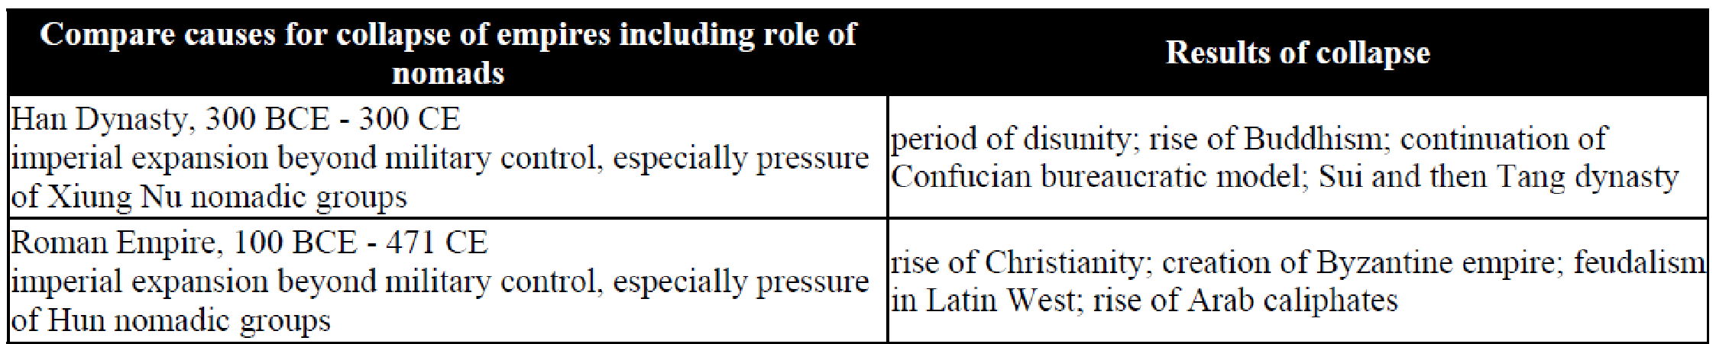

MAJOR MIGRATIONS
- Phoenicians - By about 2000 BCE this small group of seafaring people from a coastal area of the eastern Mediterranean Sea had set up colonies in North Africa and southern Europe. Pressured by both lack of space in their homeland and desire for prosperity from trade, the Phoenicians traveled widely over the entire
Mediterranean area. To facilitate their trading, they simplified the cuneiform system, producing an alphabet with 22 characters that was far easier to learn and use. Not only did the Phoenicians spread their maritime skills, but their alphabet became the basis of alphabets in Greece, Rome, and eventually for many modern languages.
- Israelites - According to Judaism, the Israelites actually originated about 2000 BCE in the Mesopotamian city of Ur with the founder of the religion, Abraham. Abraham and his family migrated to the eastern Mediterranean, where they settled in a land they called Canaan. The Jews were distinctly different from other people of the area because they were monotheistic, believing in only one god. They later migrated to Egypt to escape a spreading drought. There they became slaves, and under their leader Moses, they returned to Canaan where they eventually formed the kingdom of Israel. The Jewish religion greatly influenced the people that they contacted, although it did not actively encourage conversion of non-Jews. Jewish beliefs and traditional stories were written down and later became basic to Christianity and Islam. The religion stressed the importance of prayer, worship, and good behavior; tenets that have become characteristic of many other monotheistic religions.
- Aryans - These herding peoples originated in the Caucasus area, but they began migrating in many directions about the mid 2nd millennium BCE. Waves of Aryan migrants invaded the Indian subcontinent, decimating the cities of the Indus Valley. The Aryans remained a nomadic people for many years, but eventually pushed eastward, settling in the fertile Ganges River area as agriculturalists. The Aryans imposed their caste system on the natives, a complex social structure with strict social status differences and virtually no social mobility. Their stories also became the basis for Hinduism.
- Huns – 300-400s C.E.; originated in the Gobi Desert (China) and moved to what we now call Hungary; Pushed the natives out and the natives (Goths) started to move into Roman Empire. Attila the Hun invaded Gaul (France) in 451, but they were pushed back. They then invaded Rome in 453, but Attila died and the Hun Empire quickly collapsed.
- Germanic Peoples – found from the Black Sea to the Rhine. In 476, Odoacer, a Visigoth, officially became the leader of Rome.

Basic features of major world belief systems

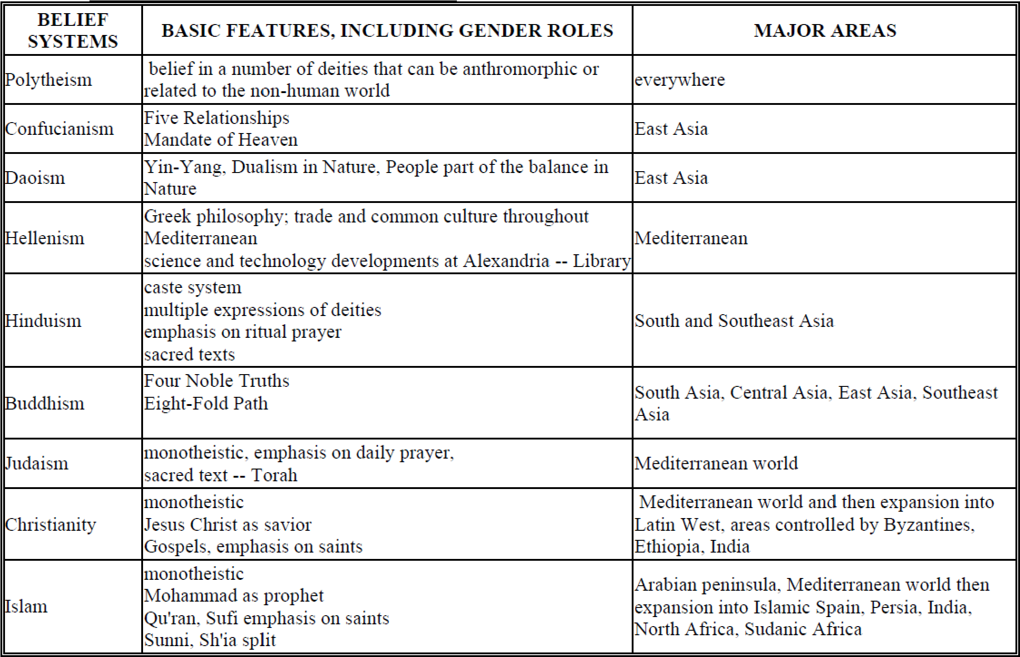

Class/Social Systems:

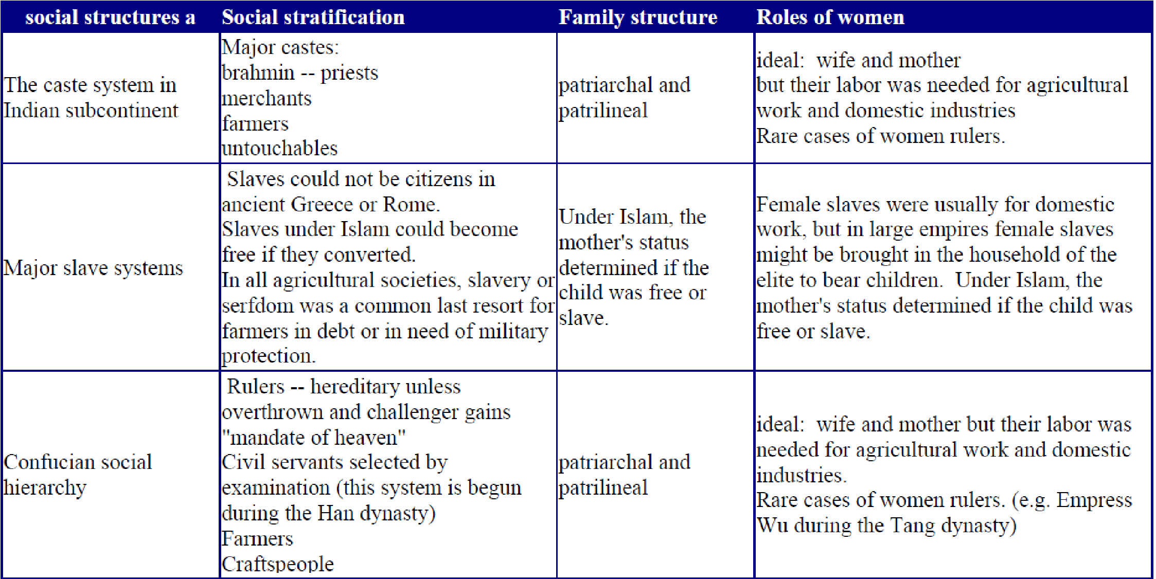

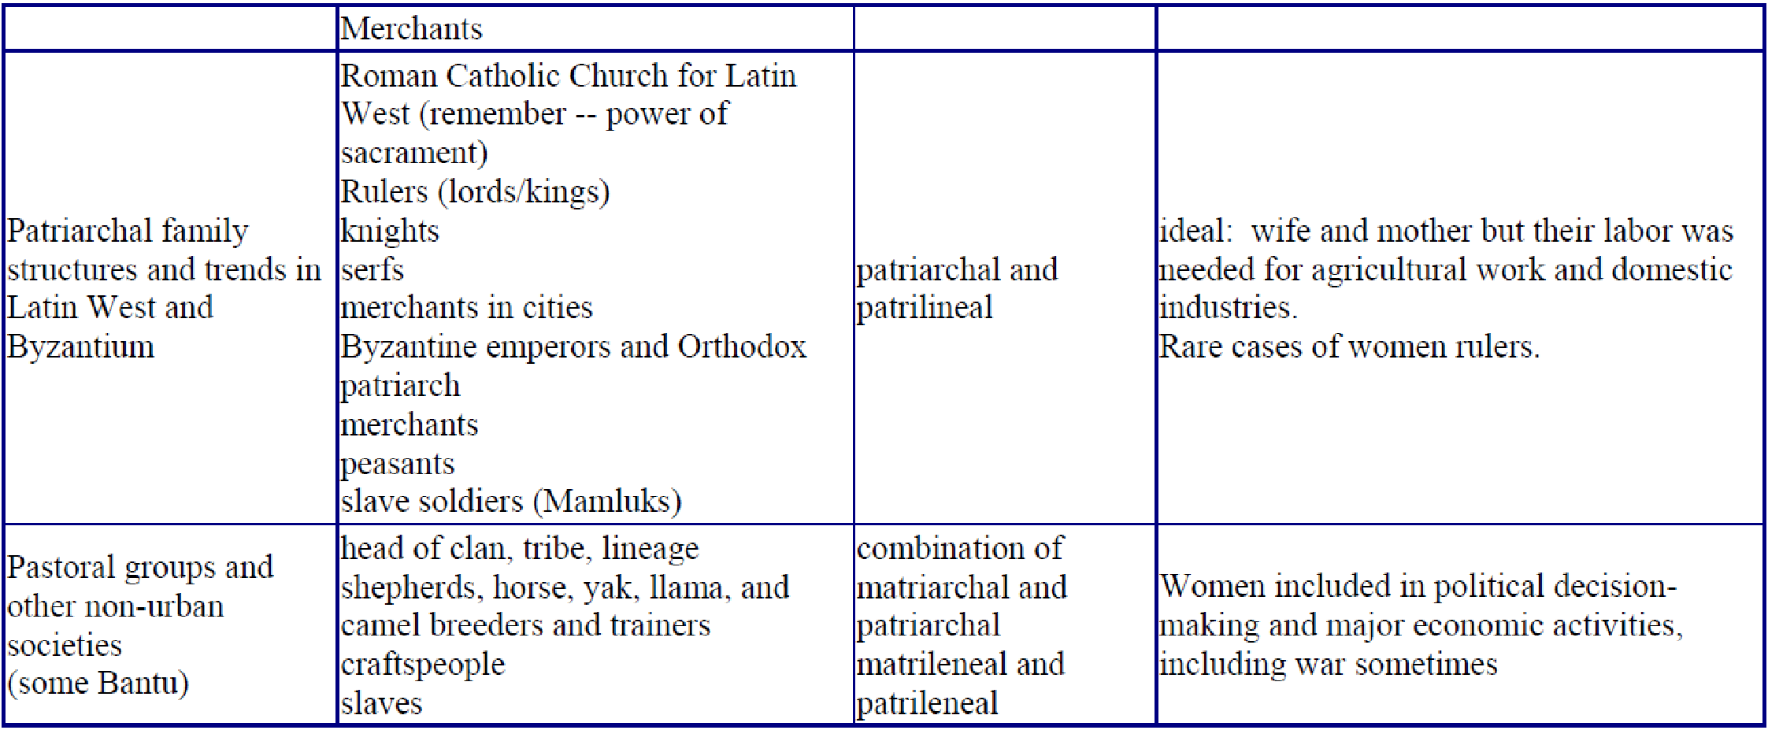
Diverse interpretations What are the issues involved in using “civilization” as an organizing principle in world history?
This is a very “politically correct” topic. Civilization is a “western word” that is defined as having: 1) a food producing based that generated surpluses, 2) an increase in population, 3) specialization of labor, 4) a social hierarchy, 5) growth of trade, 6) centralization of political and religious authority, 7) monumental building, and 8) the development of writing and written records.
Many historians would suggest that a better way of organizing world history is through studying human creativity. Civilization often implies superiority. Not all settled agricultural societies had monumental architecture or writing systems, so they appear to be "lesser" than those that did.

What is the most common source of change: connection or diffusion versus independent invention?
Major question: do civilizations develop major ideas on their own (pyramids in Egypt, ziggurats in Mesopotamia, and temples in Mayan Empire) or do they get their ideas because they had been exposed to them elsewhere. Once trading networks and missionaries travel, there's almost constant connections that lead to diffusion. Independent inventions often happened before 1000 C.E. when humans were isolated geographically from each other.

Major comparison and snapshots:
