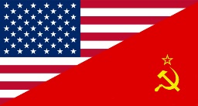
THE COLD WAR
BEGINNINGS

The Cold War
Amid the rubble of World War II, two new superpowers arose. In Europe, Nazi Germany was defeated and much of the continent was left in ruin. Even though they had fought for the winning side, the once mighty countries of France and Britain were exhausted and destroyed. As a result, two other powers- the United States and the Soviet Union- emerged as the new world leaders. During World War II, the Soviet Union (also known as communist Russia or USSR) and the nations of the West had cooperated to defeat Nazi Germany. After the war’s end, there were many conflicting ideologies and mutual distrust between communist Russia and its former ally, the United States. This led to a long period of tension and hostility known as the Cold War. The United States abandoned its traditional policy of isolationism to counter what U.S. President Truman saw as the communist threat. The Cold War dominated international affairs for decades, created a space and arms race, and caused many crises to occur. The term “cold” is used because there was no large-scale fighting directly between the two sides, but they each supported major regional wars known as proxy wars- such as the Korean War and Vietnam War. It wasn’t until 1991 (46 years after World War II) that the Soviet Union and communism fell in Eastern Europe, ultimately causing the Cold War to finally end.

Summarize the Cold War reading above in the box below in at LEAST THREE complete sentences.

Document #1

Analyze the Venn Diagram above which compares Capitalism and Communism then answer the following questions in the box below.

- Does the United States support a capitalist or communist economy?

- Did the Soviet Union support a capitalist or communist economy?

- In your opinion, what is the biggest difference between capitalism and communism?

- Why do you think this difference lead to conflicts between the Soviet Union and the United States which then created the Cold War?

- Describe the main goal of the U.S. foreign policy of containment during the Cold War.

Document #2

Analyze the above 1950s propaganda posters and then answer the following questions below.
- What caused the 2nd Red Scare (the 1st one was in the 1920s shortly after the Soviet Union formed after the Russian Revolution in 1917)?

- What was McCarthyism?

- What was the purpose of the HUAC?

Document #3

Objects:

People:

Time/Title: Communism Expanding from East to West/ The Cold War

Inferences: Because I see… ___, I can infer…

Conclusion: The most important thing in this cartoon is… ___ because it sends the message that…

***SIDE NOTE
This is the hammer and sickle symbol which was used to represent
communism and the Soviet Union

Document #4

Objects:

People:

Time/Title: The Iron Curtain

Inferences: Because I see… ___, I can infer…

Conclusion: The most important thing in this cartoon is… ___ because it sends the message that…

***SIDE NOTE
The United Nations (otherwise known as the UN) was created in 1945 after World War II as a peace keeping organization of countries around the world.
Document #5
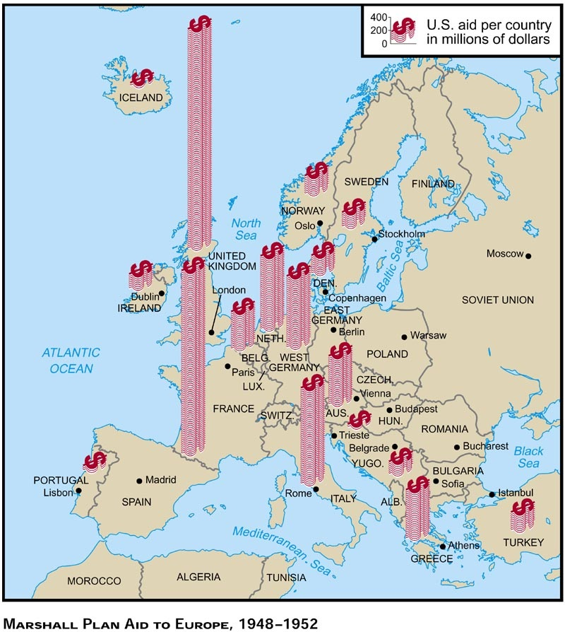

Objects:

People: Western European Countries

Time/Title:

Inferences: Because I see… ___, I can infer…

Conclusion: The most important thing in this map is… ___ because it sends the message that…

Document #6

Analyze the map of divided Germany following WWII and the political cartoon. Answer the following questions in the box below.

- The Soviet Union gained control of East Germany. Because of this, would East Germany be communist or capitalist?

- The United States, Great Britain, and France gained control of West Germany. Because of this, would West Germany be communist of capitalist?

- Where is the German capital city of Berlin located?

- The city of Berlin was also split between the Soviet Union and Western powers. Looking at the map and the political cartoon, how might this pose a problem in the future?

- What was the significance of the Berlin Airlift (1948- 1949)?

Document #7
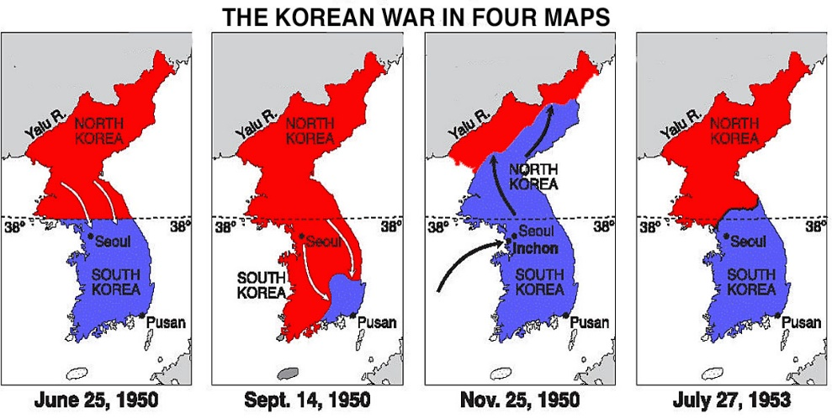

Analyze the map over the Korean War above and answer the following questions.

- What happened to the country of Korea after World War II?

- Was North Korea communist or anti-communist?

- Was South Korea communist or anti-communist?

- What did the U.S. and the United Nations do in response to North Korea invading South Korea in 1950?

- Why did China get involved in the Korean War (look at the Nov. 25, 1950 map)?

- What was the result of Korean War (1950-1953)?

Document #8

Background Information: The Soviet Union detonated its first atomic bomb in 1949 and developed the hydrogen bomb in 1955. They also launched the first artificial satellite (called Sputnik) into orbit in 1957.

- What were the causes and effects of the Arms Race?

- What were the causes and effects of the Space Race?

