Name: ___________________ Date: __________ Period: _____________

Group Members: _________________________________________________________
Second-Wave Civilizations Comparison Project

Project Expectations

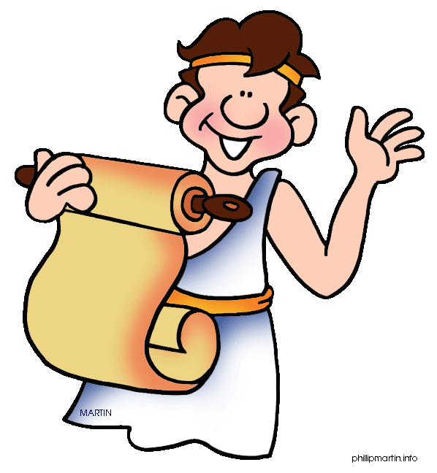
This era presents rich opportunities to compare empires, religions, social systems, art styles, and other aspects of the past, sharpening our understanding and appreciation of the varieties of human experience. This project will be a group project, with a group consisting of two or three people of your own choosing. Each group must select a unique set of two empires/civilizations to research and compare. SPICE analysis is to be divided among group members by SPICE theme and the final analysis should be a group effort.

Topics
- Persian Empire (Achaemenid)
- Indian Empire – Mauryan
- Indian Empire – Gupta
- Greek city-states and its colonies
(Other various empires, like Rome and China, will be covered in later parts of this course)

Research and Sources of Information: The Ways of the World textbook should be your primary sources for this project however you are allowed to use additional academically focused sources if you like, additional sources must be cited using MLA format.

Project Guidelines

The Poster: The final product must compare (analyze similarities and differences) the two civilizations/empires of your choosing in terms of each SPICE theme. The poster should be organized by SPICE theme and should include at least three direct comparisons per SPICE theme. (See Spice Theme Reference List) For example, when comparing the social aspects of your two empires/civilizations you might choose gender roles, social classes, and family/kinship to focus on.

Step 1: Select your empires and conduct in-depth research regarding each of your chosen civilizations/empires. Be sure to consult SPICE themes in your search. (Again, you must include up with three comparisons PER SPICE THEME). Organize your research on the table on the next page.

What is an “empire?” A frequently used method to study and compare empires is the Conrad-Demarest Model of Empires developed by historians Geoffrey W. Conrad and Arthur A. Demarest in their book, Religion and Empire: The Dynamics of Aztec and Inca Expansionism. The model states that empires have the four stages listed below - Be sure to consider each stage of your empires in your research.
- Preconditions for the rise of an empire
- Building of the empire and a unifying ideology
- Rewards of the empire
- Fall of the empire

Step 2: Create a divided SPICE Analysis Poster defining a civilization and then showcasing each civilization/empire’s unique characteristics. Be sure to include features that had long-lasting effects on their development. Responses on your poster should be in complete sentences, neatly written or typed, and neatly organized/easy to follow. Be sure to complete at least three SPICE Comparisons, comparing and contrasting each of your civilizations/empires as they relate to each SPICE theme. As you determine your comparisons, consider the following:
- What common features can you identify in the civilizations/empires you have chosen?
- In what ways did they differ from one another?
- What accounts for those differences?
- In comparing these civilizations/empires, which do you find more striking- their similarities or their differences?

RESEARCH OUTLINE
What is a “civilization” and what were common characteristics of civilizations during the classical era? |  |  | What is an “empire” and what were common characteristics of empires during the classical era? Why are they significant?
 | Civilization/Empire 1 | Civilization/Empire 2 |  | Points of Comparison Per Spice Theme
Social |  |  |  | Similarities
 |  |  |  | Differences
Political |  |  |  | Similarities
 |  |  |  | Differences
Interaction |  |  |  | Similarities
 |  |  |  | Differences
Cultural |  |  |  | Similarities
 |  |  |  | Differences
Economic |  |  |  | Similarities
 |  |  |  | Differences
Evaluation:
Step 3: On the bottom of your poster, complete an overall evaluation of each of your civilizations/empires. Be sure to consider all of the SPICE theme facts and comparisons in your response. Each answer should reference specific pieces of evidence to support your analysis.

- For civilization/empire 1, are you more impressed with the “greatness” of the empire or with its destructive and oppressive features?
  - What preconditions gave rise to the empire?
  - What methods were used in the building the empires? What created a unifying ideology?
  - What were the rewards of participating in the empires?
  - What led to the fall of the empire?

- For civilization/empire 2, are you more impressed with the “greatness” of the empire or with its destructive and oppressive features?
  - What preconditions gave rise to the empire?
  - What methods were used in the building the empires? What created a unifying ideology?
  - What were the rewards of participating in the empires?
  - What led to the fall of the empire?

- Overall, identify and explain which civilization/empire will have a greater impact – either positively or negatively - on future civilizations in the same geographic area. Does the impact reach into the modern era?

Rubric:
 | Score | Comments/Names
Overview: What is a Civilization? What is an empire? | ___/20
SOCIAL  Civilization 1 Overview  Civilization 2 Overview  Three direct comparisons | ___/5  ___/5  ___/15
POLITICAL  Civilization 1 Overview  Civilization 2 Overview  Three direct comparisons | ___/5  ___/5  ___/15
INTERACTION (environment)  Civilization 1 Overview  Civilization 2 Overview  Three direct comparisons | ___/5  ___/5  ___/15
CULTURE  Civilization 1 Overview  Civilization 2 Overview  Three direct comparisons | ___/5  ___/5  ___/15
ECONOMIC  Civilization 1 Overview  Civilization 2 Overview  Three direct comparisons | ___/5  ___/5  ___/15
Final Analysis/Overall Evaluation  Depth of analysis, plausible historical argument based in evidence, alternatives acknowledged. | ___/10  ___/10  ___/10
Poster Layout: Neat, organized, artistic effort (25 points)  Attention to detail, overall project with obvious plan and layout used, titles clear, drawings or other additions add to the overall appearance. | ___/25
Above and beyond (extra credit)
SPICE Themes Reference Chart:

Social – Development and Transformation of Social Structures

- Gender roles and relations
- Family and kinship
- Social classes or structures
- Norms that govern interactions

Political – State-Building, Expansion and Conflict

- Official origin
- Political structures, forms of governance, or systems of rule
- Development and expansion, including empire-building
- Internal and external conflicts
- Organizational and cultural foundations of stability
- Interstate relations, including warfare, diplomacy, commercial and cultural exchange, and the formation of international or regional alliances

Interaction – Interaction Between Humans and the Environment

- Geographical features
- Environmental factors such as rainfall patterns, climate, and available flora and fauna
- Natural resources
- Food sources
- Demography and disease
- Migration
- Settlement
- Technology
- Human exploitation of and/or impact on the environment
- Transportation

Cultural – Development and Interaction of Cultures

- Religions
- Belief systems, philosophies, ideologies, and values
- Science and technology
- Art and/or decoration
- Clothing and/or regalia
- Ceremonies
- Architecture
- Exchange of culture with other groups
- Differences/similarities with other cultural groups, including those within the same region

Economic – Creation, Expansion and Interaction of Economic Systems

- Agricultural and pastoral production
- Trade and commerce
- Systems of value or currency
- Labor systems
- Industrialization
- Economic ideologies, values or systems, such as capitalism or socialism (distribution of wealth)

