CREATE A GAME BOARD PROJECT
CONTENT OBJECTIVE: Students will identify major events, individuals, dates, documents, and cause-and-effect relationships during the world wars (World War I and/or World War II) by creating a TRIVIA board game with at least 30 questions ranging from lower to higher-level thinking skills.

DIRECTIONS
1. Students will get into groups of no more than five. Using online resources, vocabulary lists, class notes, and the AMSCO textbooks, each group will research World War I and World War II in order to create a game board representing early 20th century global conflicts.

2. Students will brain storm with their group using a thinking web diagram to discuss and review significant individuals, events, documents/rulings, dates, and causes/effects during the world wars that should be included on their TRIVIA game board.

3. GUIDELINE CHECKLIST
Students may create/design any type of gameboard as long as it meets the following:
- Is a TRIVIA boardgame over World War I and/or World War II (This game has to test the knowledge of other students. It must include relevant and factual information)
- Board games can focus on just one of the world wars or a combination of both
- Must contain at least 30 trivia questions (5 easy, 15 moderate, 10 higher-level thinking); levels must be written below each question with answers listed on the back or separate sheet of paper
- Includes at least 7 illustrations/pictures of historical individuals/events/places from that time period (1914-1945)
- Includes detailed, organized, and easy to follow directions for your game
- This must be a tangible/physical game (i.e. no Kahoot/jeopardy game online)
- Gameboard is no larger than a regular sized poster board
- Includes ALL NECESSARY PIECES
- Be creative, but don’t make your game so complex it takes a class period to figure out how to play
4. Projects are due Thursday/Friday May 11th/12th at the beginning of class. Groups will play each other’s game boards to review the world wars.

QUESTION EXAMPLES
THINK SEPTIC THEMES
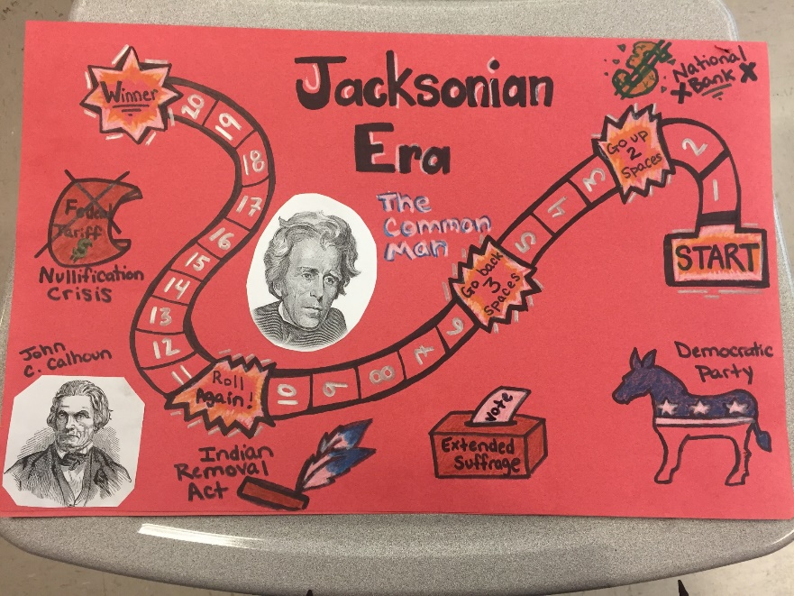
Easy Level Question
*When did World War I start?*
(Who, what, when, where, why type questions)

Moderate
*What were three major effects of the Treaty of Versailles that ended World War I?*
(Causes, effects, fill in diagram/thinking web, significance, summarize, give an example, exc.)

High-Level Thinking
*Compare the effects of World War II on Africa and Asia between 1945-2000.*
(Compare/contrast, continuity/change over time, analyze primary source quote/political cartoon, evaluate point of view, connections across time periods, exc.)
Board Game Rubric
Components | Level 1 | Level 2 | Level 3 | Level 4
Question Cards  *Each card must be marked higher, medium, or lower level  *Groups can have more than 10 higher level questions | 5 points  *1-9 total question cards with correct answers  *0-3 higher level  *0-5 medium  *0-1 easy  (See question examples) | 10 points  *10-19 total question cards with correct answers  *4-6 higher level  *6-9 medium  *2 easy  (See question examples) | 20 points  *20- 29 total question cards with correct answers  *7-9 higher level  *10-14 medium  *3-4 easy  (See question examples) | 30 points  *30 total question cards with correct answers  *10 higher level  *15 medium  *5 easy  (See question examples)
Board | 5 points  *1-9 spaces  *0-3 historical individuals/events illustrated | 10 points  *10-14 total spaces  *4 historical individuals/events illustrated | 15 points  *15-19 total spaces  *5 historical individuals/events illustrated | 20 points  *20 total spaces  *At least 7 historical individuals/events illustrated
Accuracy | 0 points  *More than 5 mistakes are made on the board or question cards (wrong answers, events/individuals are in the wrong era) | 5 points  *3-4 mistakes are made on the board or question cards (wrong answers, events/individuals are in the wrong era) | 10 points  *1-2 mistakes are made on the board or question cards (wrong answers, events/individuals are in the wrong era) | 15 points  *Board, illustrations, and question cards belong to the correct era  *Each question card has the correct answer on the back
Creativity/  Organization | 0 points  *Board/project is incomplete, messy, shows little to no effort and/or is disorganized | 5 points*  *Board/project is complete but is unorganized and/or lacks creativity (i.e. illustrations are weak) | 10 points  *Board/project is complete and neat but lacks some creativity or originality | 15 points  *Board, illustrations, and question cards are clean, neat, and organized  *Project shows a high level of originality and effort
Peer Grade | 5 points  *Peer grades falls between a score of 0-69 | 10 points  *Peer grades falls between a score of 70-79 | 15 points  *Peer grades falls between a score of 80-89 | 20 points  *Peer grades falls between a score of 90-100

