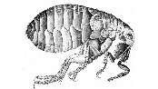
BLACK PLAGUE DIARY PROJECT (1347-1351)
Students will produce their own individual series of Black Plague diaries as if they were living in Europe in June of 1349.

Components
- Each project needs a brief one paragraph introduction (minimum 5 complete sentences) introducing the student’s character which covers the following:
  - Character’s name, clergy or noble title (since you are one of the few literate people in Europe at this time), where they are from, and any additional background information you would like to include
  - Where they are traveling to and purpose for their journey
  - Fellow travelers that accompanied your character’s journey
- At LEAST FIVE diary entries over your journey throughout Europe in June of 1349. Each diary entry must be at least one complete paragraph (minimum 5 sentences).
- Diary entries must be in chronological order and list the month, year, and town the student has traveled to.
- Each journal entry must be detailed and reflect issues, events, people, and places present during this time period. Students will have to RESEARCH the following ideas and incorporate them into their journal entries:
- Events directly leading up to the Black Death in Europe (such as increase of trade/guilds, changing agricultural economy, urbanization, gothic cathedrals, new intellectual movements like universities and scholasticism)
- Signs and symptoms of the Bubonic Plague (bubonic plague vs pneumonic plague)
- The public’s reaction and attitudes towards the Bubonic Plague (such as medical knowledge of the time period, sanitation standards, how people tried to “cure” or curtail (limit) the disease, the Catholic church’s role, persecution of Jewish populations, exc.)
- Cities that were most dramatically affected by the disease AND WHY.
- At LEAST ONE significant individual AND event during that time period.
- Overall effects of the Black Death on Europe (such as the effect on the manorial economy/feudalism)
- If a student traveled with a group, it would be important to include the fate of the fellow travelers and emotional reaction to their loss.
- While this is a creative writing assignment, diary entries must include factual information that is relevant to this time period. (Use your imagination, but don’t make up things that never happened)
- Diary entries can be typed or neatly hand written, but should be organized and show a high level of effort and critical thinking.
- EXTRA CREDIT can be earned if their diary takes on a weathered appearance. Appropriate doodles are encouraged as well.
DUE DATE: FRIDAY NOVEMBER 22

Rubric | 25 points | 20 points | 15 points | <10 points
Diary Completion | Diary is thorough, detailed, and has all required components: introduction and 5 diary entries with month, date, and places visited. Writing is articulate. | Diary has all required components: introduction and 5 diary entries but some entries may be lacking complete paragraphs | Diary is missing one component (i.e. an introduction or only has four diary entries) | Diary is missing two or more components
Research: Factual and Relevant Information | Diary shows a high level of critical thinking and research: all 4a-f components are included and each entry has detailed/well explained factual and relevant information from this time period | All 4a-f components are included and each entry has factual and relevant information from this time period | Diary has one or two factual errors or does not go into great detail with 4a-f components | Diary is missing several 4a-f components
Organization and Presentation | Diary is in chronological order, follows the in-class simulation, and covers all towns visited. Diary is typed or neatly hand written while showing a high level of effort and skillful presentation. | Diary is in chronological order, follows the in-class simulation, and covers all towns visited. Diary is typed or neatly hand written. | Diary lacks some organization or is not typed and neatly hand written (i.e. written last minute on lined paper) | Diary has little to no organization and is poorly prepared
Creativity | Diary shows a high level of originality, effort, and dedication. Student used a great deal of imagination while maintaining character and staying true to the events that transpired during that time period. | Diary shows a moderate level of creativity, effort, and dedication. | Diary lacks creativity and originality. | Little to none originality is shown.
Example Format (Bound Book Idea)
Cover Introduction (Page 1)

Lord Geoffrey
1349 Journal

Student’s Real Name
Period 1

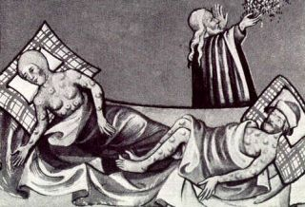

This diary belonged to Lord Geoffrey who was to become the Earl of Essex in England. He was born in 1324 and was educated by…

Being a young man who craved entertainment and adventure, he traveled in the month of February to Venice for the annual Carnival festival. Though after acquiring a substantial amount of gambling debt and feeling the urge to see more of Europe, he embarked on a trading voyage… in order to….and hoped to finish his journey in Liverpool, England.

He was accompanied by his loyal servants…

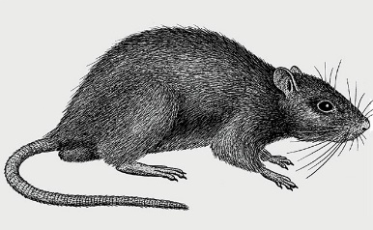

First Diary Entry (Page 2) Second Diary Entry (Page 3)
July 1349
Rome and the Republic of Genoa,

After spending four nights in Cagliari, we traveled to Rome and now we are currently in the Republic of Genoa…
Nothing as horrible since the fall of the great Roman Empire in 476 has plagued or world…

(Cagliari and Rome were highly infected)

(Pope Clement VI?)

Contracted Black Plague

Third Diary Entry (Page 4) Fourth Diary Entry (Page 5) Fifth Diary Entry (Page 6)

July 1349
Barcelona, Crown of Aragon

(Anti-Semitic attitudes accompanied the Reconquista. There were mass killings in Aragon in the mid-14th century, and 12,000 Jews were killed in Toledo.)

Died here
July 1349
Algiers

(Spanish Reconquista- Expulsion of the Moors from the Iberian Peninsula)

Black Plague symptoms appear

July 1349
Tunis, Hafsid Dynasty

We have arrived in the North African city of Tunis which is controlled by Sunni Muslims of Berber decent…

(Ibn Battuta?)

(Tunis was highly infected)
June 1349
Marsala, Sicily

After spending my final five nights in Venice, my loyal servants and I traveled to Marsala in the Kingdom on Sicily….

Only a few years ago, many in Europe were… trade was flourishing in these regions of Italy but ever since the onset of this terrible curse in 1347…

(Notice disease and people’s reactions)

